Command Line üzerinden bilgisayarı domain’e almak

netdom.exe join %computername% /domain:DomainName /UserD:DomainName\UserName /PasswordD:Password4

Powershell üzerinden

Add-Computer –DomainName yigitaydog.local

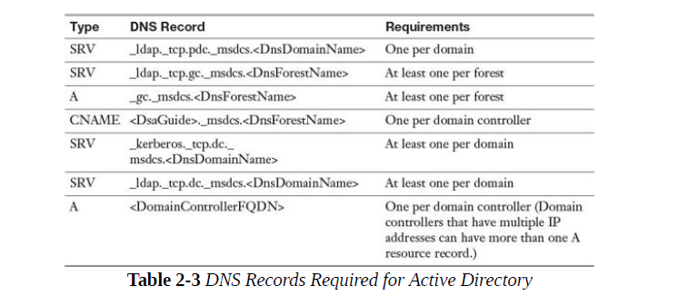

DC nin guid numarasını bulmak: HKLM>Software>Microsoft>Cryptography

Global Catalog>> to find things in AD

DC> static IP address

Installing AD

AD DS rolünün kurulması:



DC on new forest>> add a new forest

**Import-Module ADDSDeployment**

**Install-ADDSForest  
-CreateDnsDelegation:$false  
-DatabasePath “C:\Windows\NTDS”  
-DomainMode “Win2012R2”  
-DomainName “yourdomain.com”  
-DomainNetbiosName “YOURDOMAIN”  
-ForestMode “Win2012R2”  
-InstallDns:$true  
-LogPath “C:\Windows\NTDS”  
-NoRebootOnCompletion:$false  
-SysvolPath “C:\Windows\SYSVOL”  
-Force:$true**

**Daha sonra DSRM şifresi girilir**

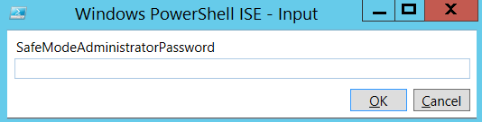

Adding DC to child domain

#  
# Windows PowerShell script for AD DS Deployment  
#

Import-Module ADDSDeployment  
Install-ADDSDomain `  
-NoGlobalCatalog:$false `  
-CreateDnsDelegation:$false `  
-Credential (Get-Credential) `  
-DatabasePath "C:\Windows\NTDS" `  
-DomainMode "Win2012R2" `  
-DomainType "TreeDomain" `  
-InstallDns:$true `  
-LogPath "C:\Windows\NTDS" `  
-NewDomainName "testdomain.local" `  
-NewDomainNetbiosName "TESTDOMAIN" `  
-ParentDomainName "yigitaydog.local" `  
-NoRebootOnCompletion:$false `  
-SiteName "Default-First-Site-Name" `  
-SysvolPath "C:\Windows\SYSVOL" `  
-Force:$true

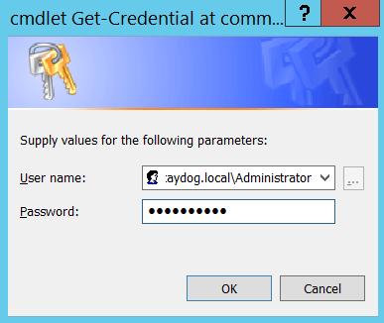

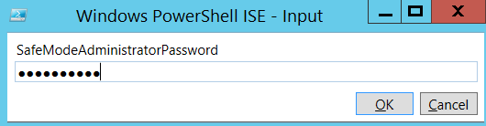

Add additional DC to existing forest (tree domain)

#  
# Windows PowerShell script for AD DS Deployment  
#

Import-Module ADDSDeployment  
Install-ADDSDomainController `  
-NoGlobalCatalog:$false `  
-CreateDnsDelegation:$false `  
-Credential (Get-Credential) `  
-CriticalReplicationOnly:$false `  
-DatabasePath "C:\Windows\NTDS" `  
-DomainName "yigitaydog.local" `  
-InstallDns:$true `  
-LogPath "C:\Windows\NTDS" `  
-NoRebootOnCompletion:$false `  
-ReplicationSourceDC "DC1.yigitaydog.local" `  
-SiteName "Default-First-Site-Name" `  
-SysvolPath "C:\Windows\SYSVOL" `  
-Force:$true

RODC (read-only domain controller)

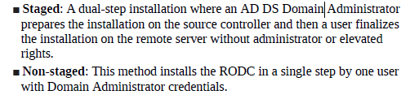

Create a site for branch office and assign RODC there

Non-staged: Domain Admin kendi credentiallarını kullanarak başka makine üzerine kurar

Staged: delegasyon yoluyla yetkisiz kullanıcı hesabı RODC’u kurar

1. Admin yetkileri olmayan kullanıcının yaratılması

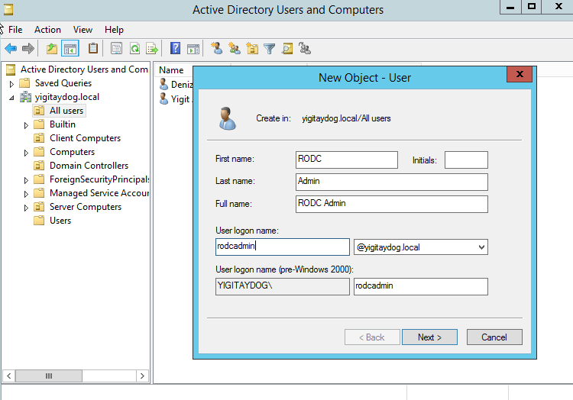

1. RODC kurulması (bu işlem sırasında RODCyapacagımız sunucu domain üyesi değil)

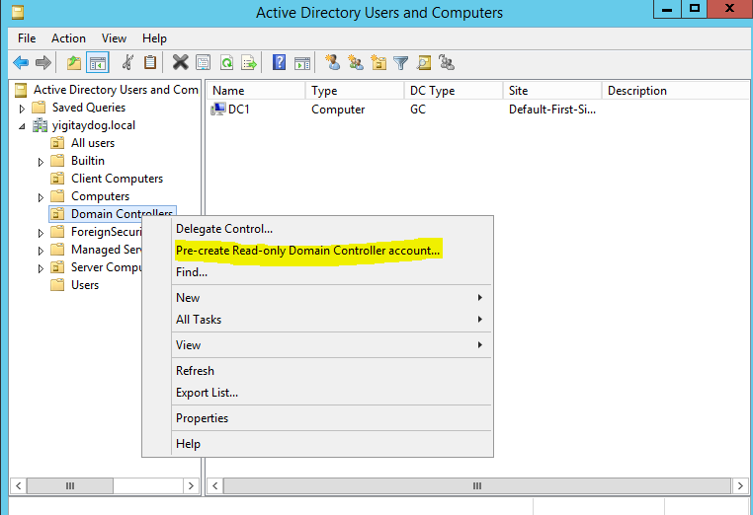

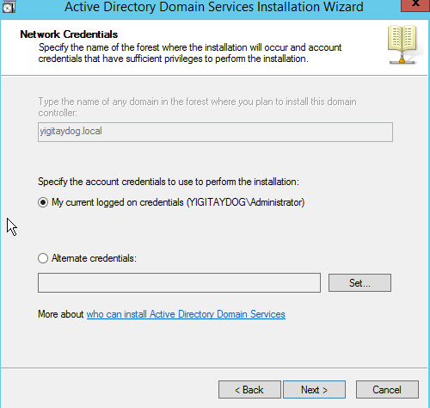

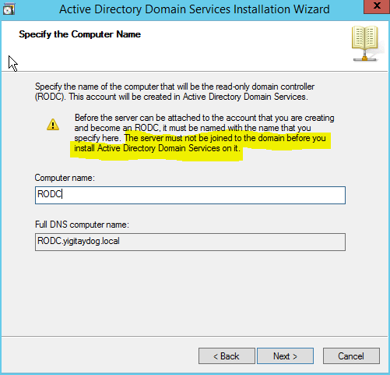

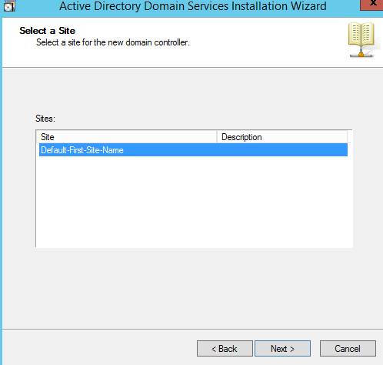

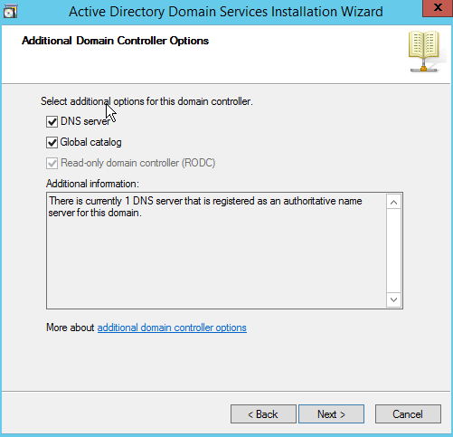

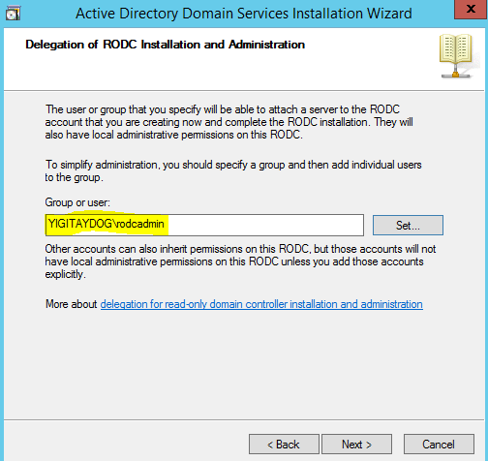

RODC sunucusuna AD DS rolü kurulur

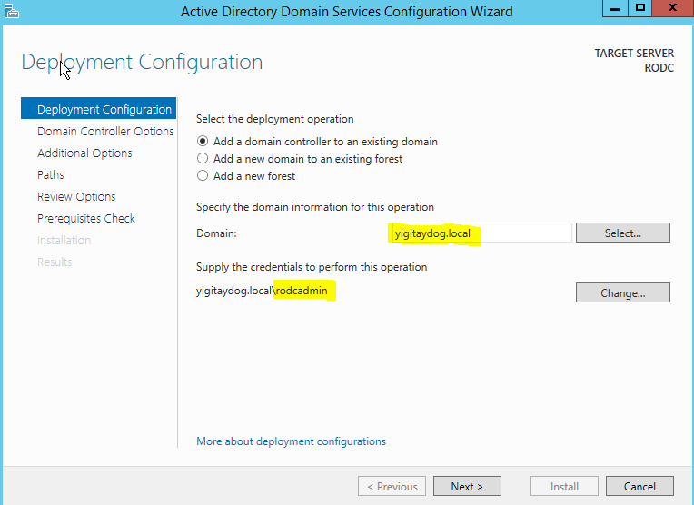

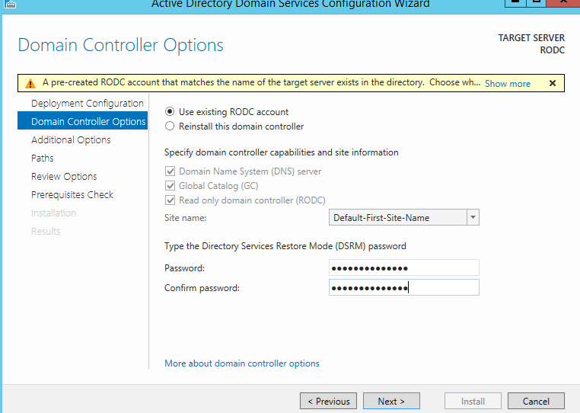

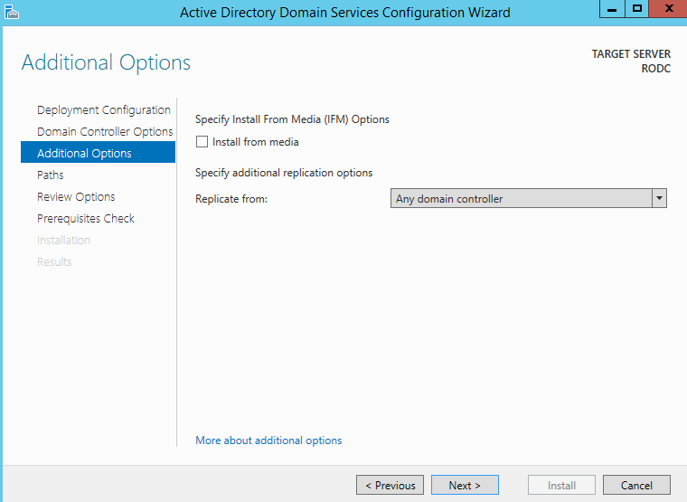

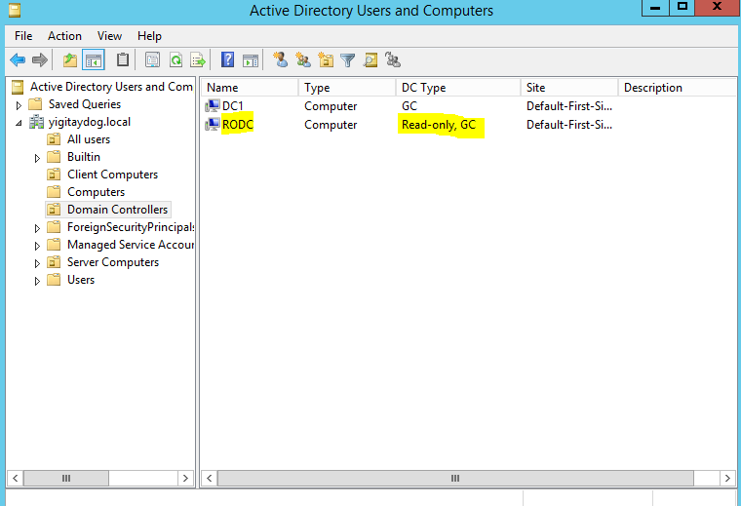

**REMOVING AD DS**

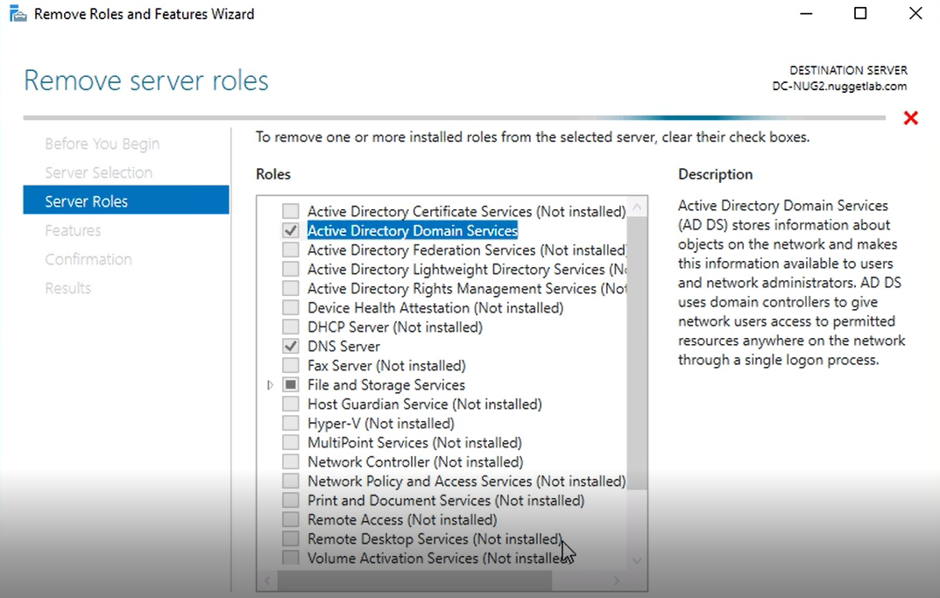

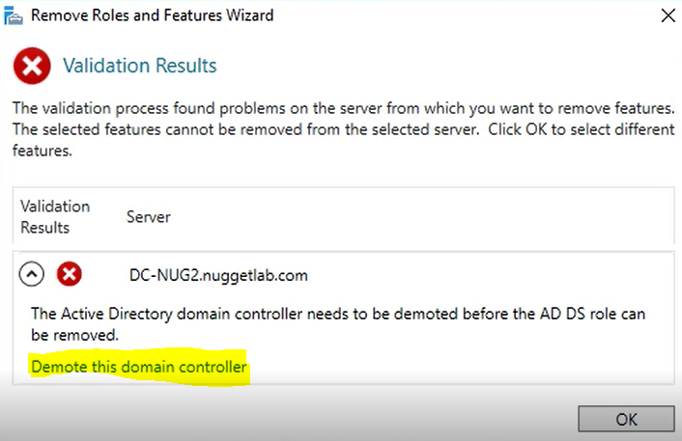

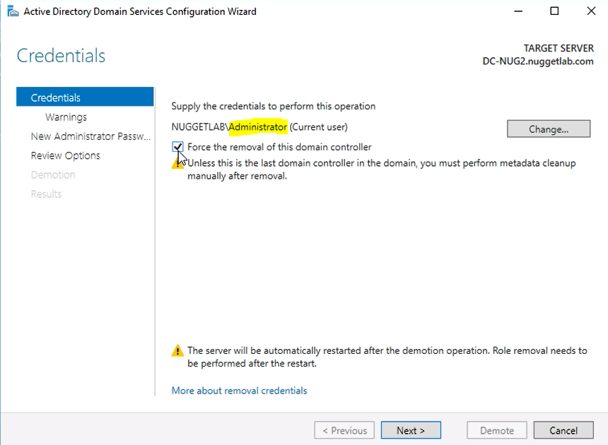

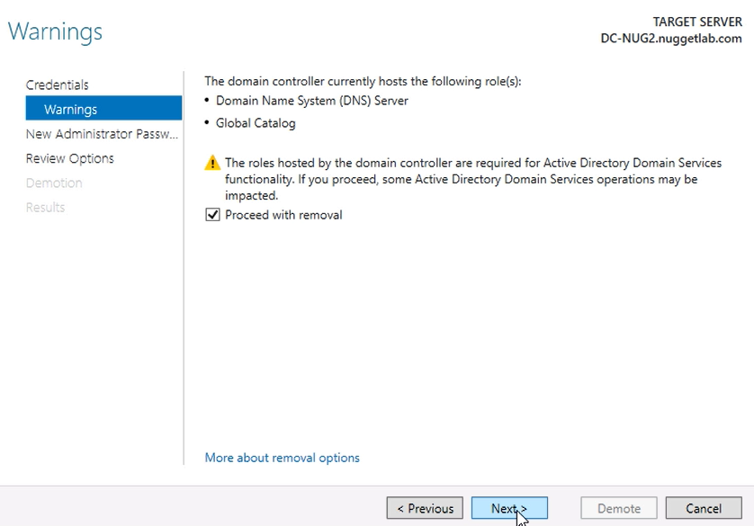

Local admin şifresi verilir,

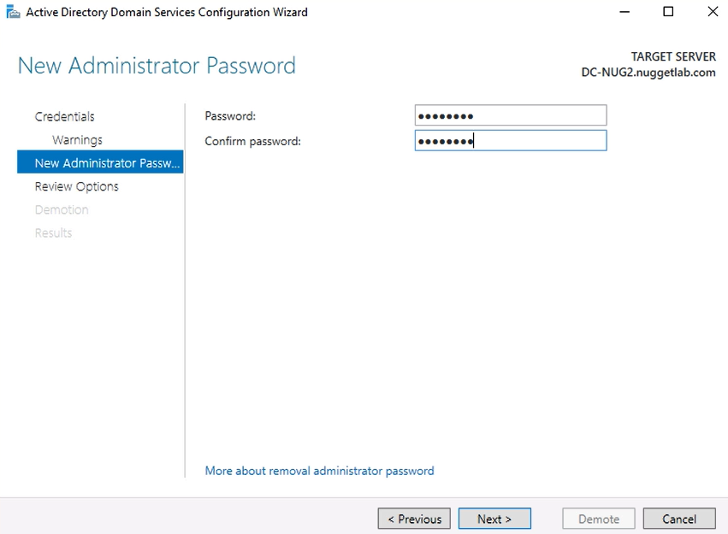

Reboot sonrası local admin le sunucuya girilir

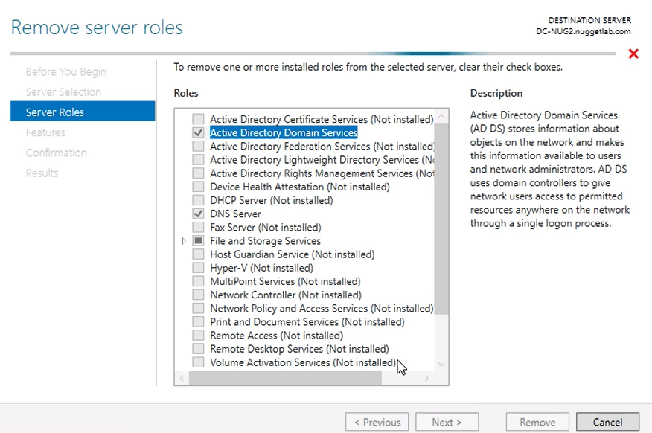

Bu işlemden sonra sunucu, domain’e üye herhangi bir sunucu gibi olur

Installing DC from Media (IFM)

Slow link @ branch office or remote location

Merkezi DC den replikasyonu azaltmak için

Ana DC’de

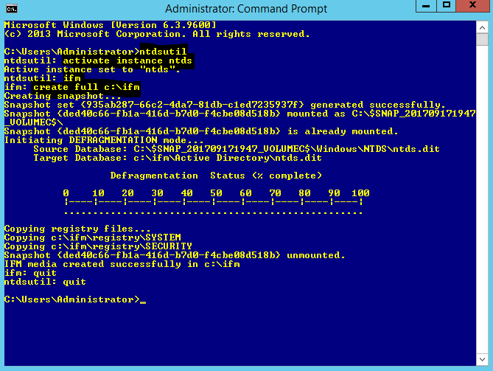

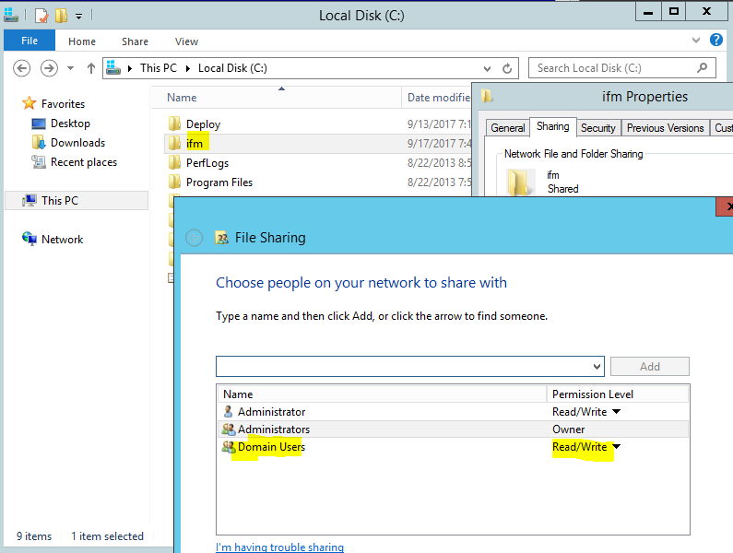

Bu klasör DC yapılacak bilgisayarın lokaline alınır (bu klasörde ntds.dit ve registry dosyaları bulunur

AD DS rolü kurulduktan sonra

Promote this server to DC konsolunda

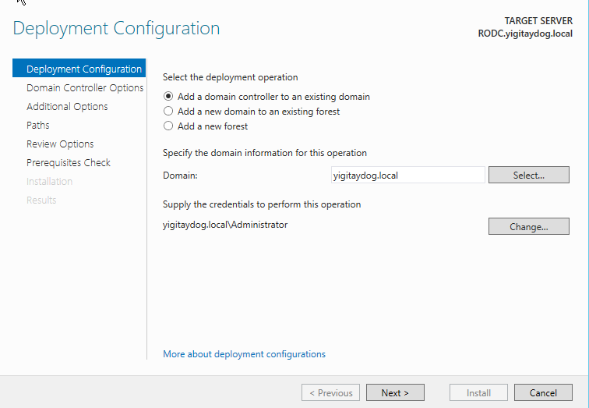

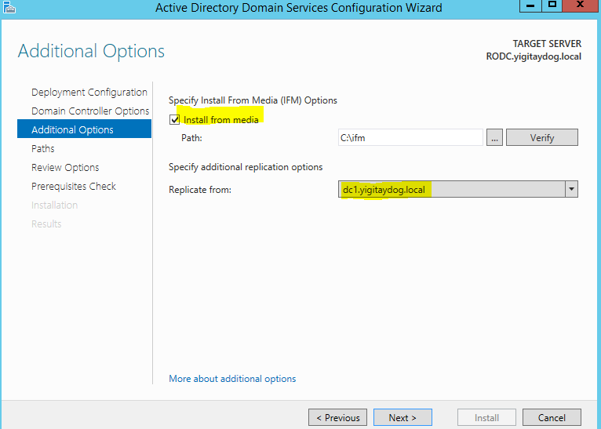

Ifm dosyasının yaratılmasından sonra AD de gerçekleşecek değişilikler, dc1 dan yine replike edilecek

**Upgrading DC**

Tüm DC’ler bir üst sürüme geçmeden aktifleştirilemez

DC kurulumu sırasında forest ve domain functional level seçilmişti eğer bir üste seviye seçildiyse yükseltme işlemi yapılabilir

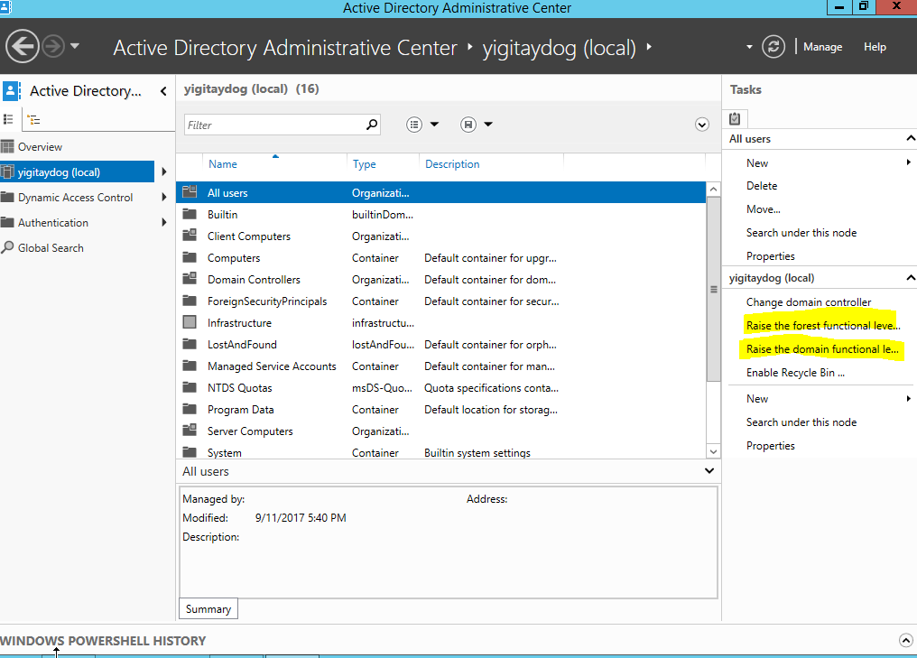

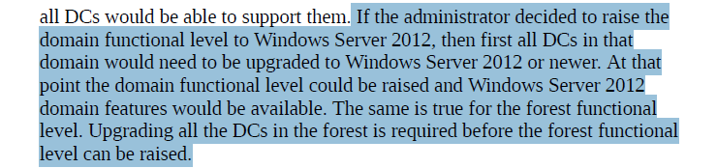,

**FSMO Roles**

Optimal yerleşim

* Schema ve domain naming master beraber bir GC üzerinde olsun
* RID ve PDC beraber olsun
* Infrastructure GC olmayan bir DC üzerinde olsun

Netdom query dc>> domain controller’ları görmek

Get-adforest

Get-addomain

Schema master

Scope: Forest wide

Purpose: logical structure of AD, how components are made up

Only one

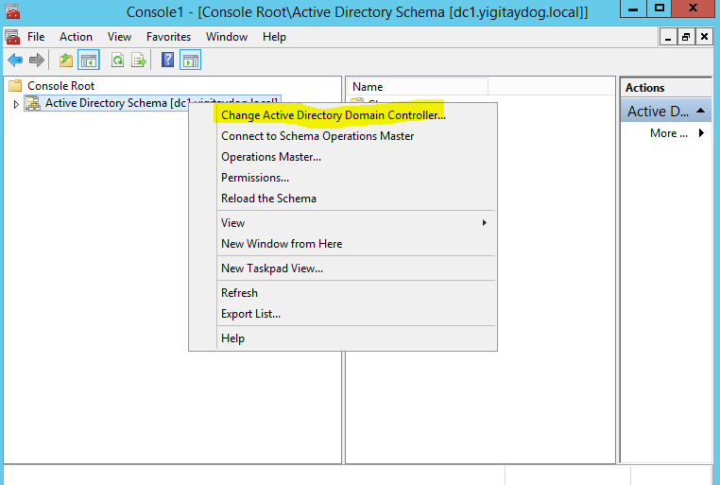Transfering schema master role from one DC to another DC

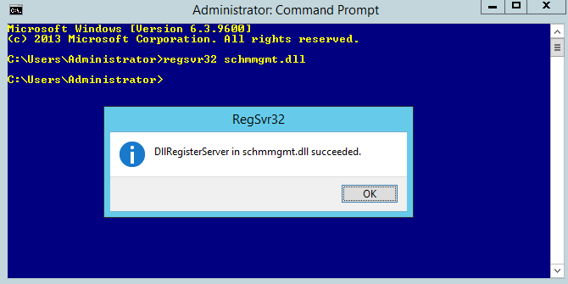

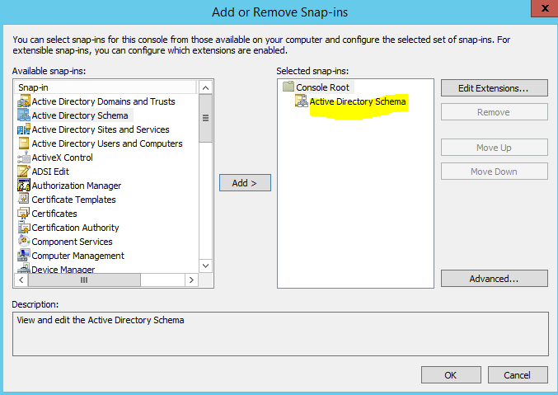

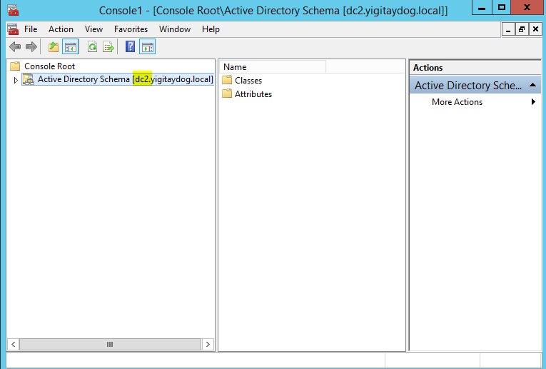

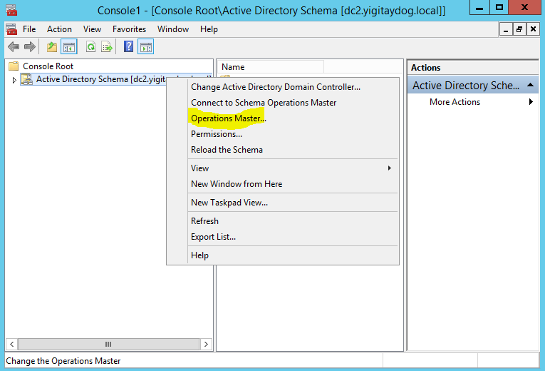

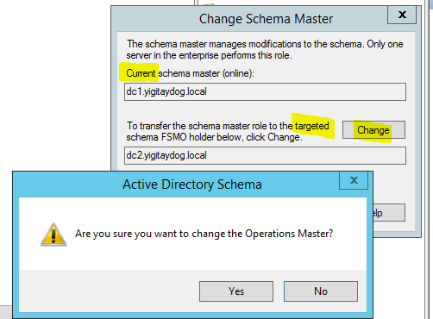

Domain Naming Master

Yeni domain yaratıldığında, domain ismi değiştirildiğinde

Scope: Forest wide

Purpose: naming

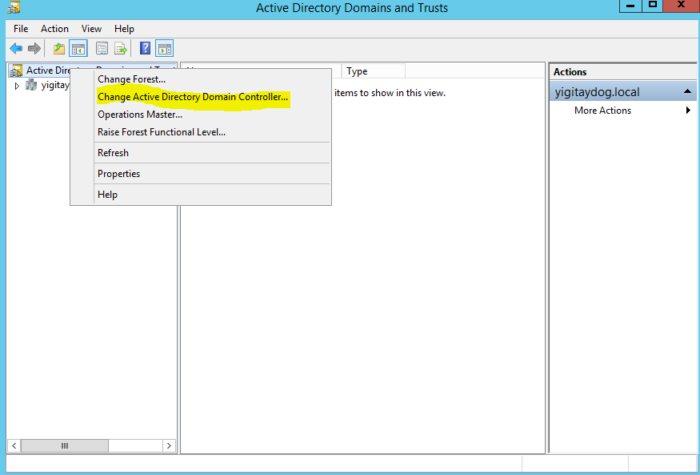

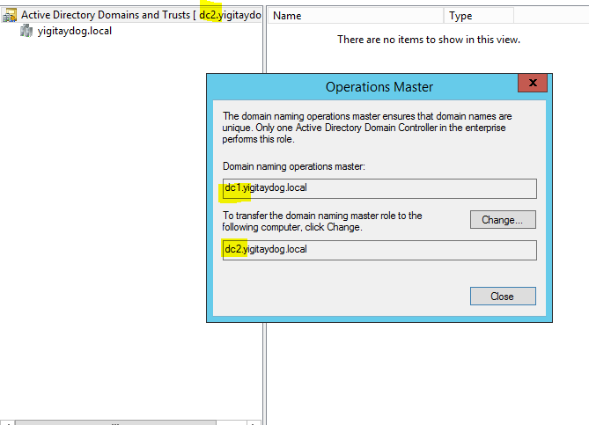

PDC Emulator

Scope: domain

Keep online!

Backwards compatibility with old domain controllers

Maintain latest password for account

GPO management tool

Master time zone

Authorization agent for dc cloning

Domain master browser

Infrastructure master

Updating sid

Check in global catalog so that it doesn’t have stale info

Keep online!

RID master

Ensures Security Identifiers (SID)s of DC in domain are unique

Relative ID

When user device accounts created, other domain controllers produce unique id

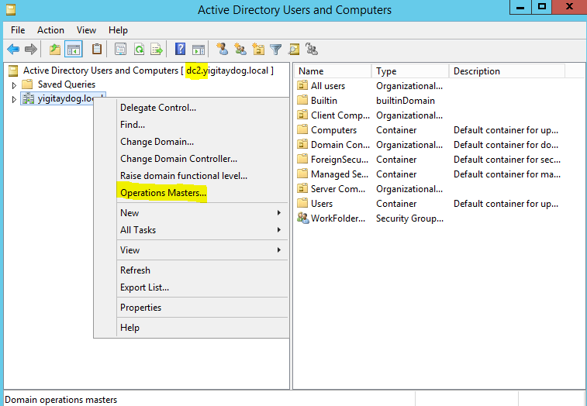

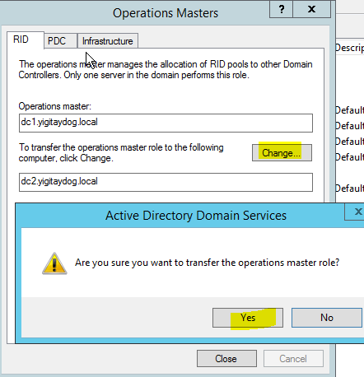

Tüm rollerin hangi DC’lerde olduğunu görmek

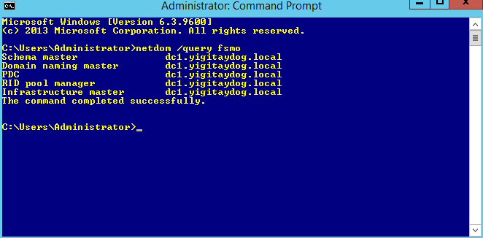

From powershell role transfer

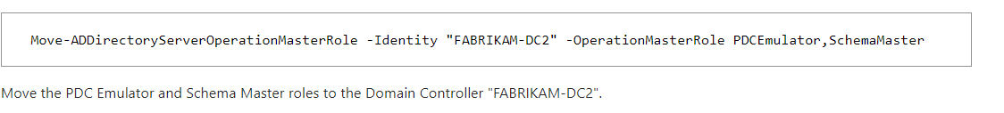

**DC Cloning**

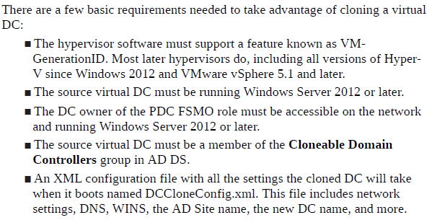

* Get-ADDCCloningExcludedApplicationList –Generate xml –Force –path C:\windows\ntds

Get list of all running application and services on computer

* New-ADDCCloneConfigFile

Clone’nun alacağı Parameters ipv4address (unused), ipv4DnsResolver (dc1), ipv4SubnetMask, CloneComputerName, ipv4DefaultGateway, path(c:\windows\ntds), sitename(default-first-site-name)

* Clone’lanması istenen fiziksel dc,’nin bilgisayar hesabı “cloneable domain controllers” hesabına üye olmalıdır
* Export original DC then import it with

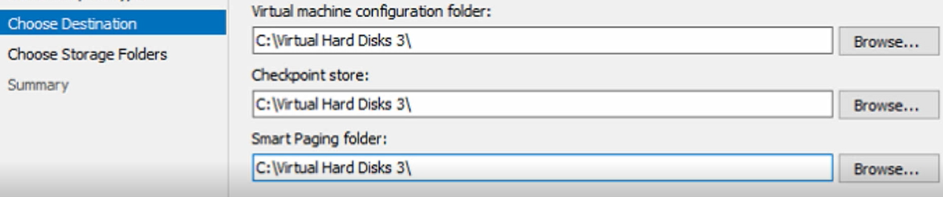

* Run new VM

**Configuring Global Catalog server**

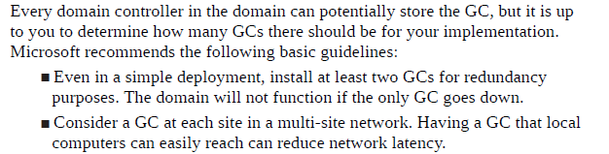

In a single domain environment, every DC should host the GC because every domain controller already holds a complete copy of the domain. In a multi-domain scenario, you need to consider user sign in times, program dependencies, GC high availability and replication traffic when planning GC placement.

Global catalog settings

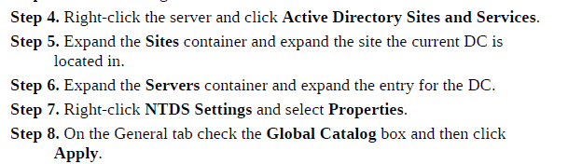

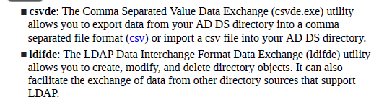

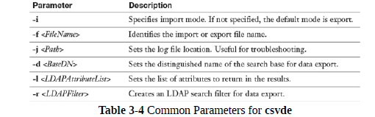

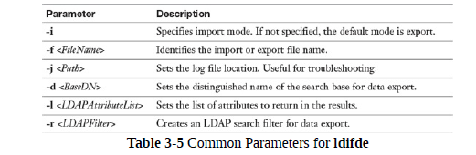

**manage group membership using Group Policy**

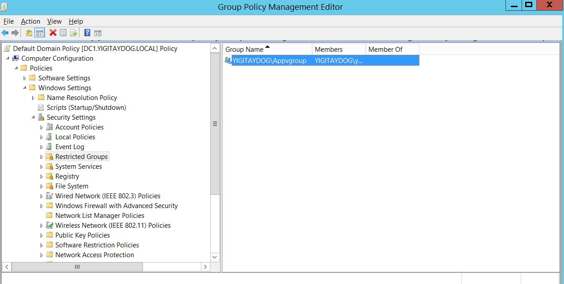

Gpupdate yapıldıktan sonra kullanıcılar bu gruba eklenmiş olur

Kullanıcı gruptan çıkarılsa bile gp update geldiğinde kullanıcı tekrar üye olur

**universal, domain local, and domain global groups**

Groups belong to one of three scopes:

**Universal**: Groups with a universal scope can have as a member any user account from any domain within the forest, as well as other global or universal groups in the forest. Universal groups can grant permissions to any resource in the forest.

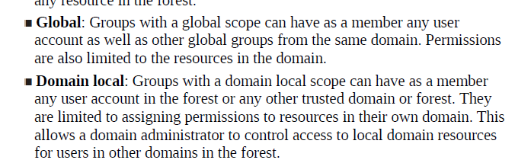

Yapınız tek bir site altındaysa Group Scope'un Domain Local, Global veya Universal olmasının bir önemi yok. Fakat yapınızda birden çok site mevcut ise farklılıklar göstermektedir.

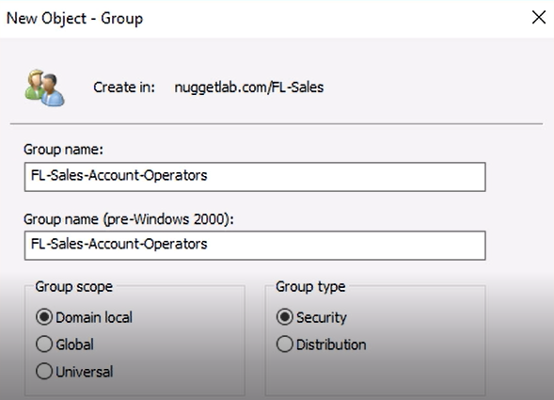

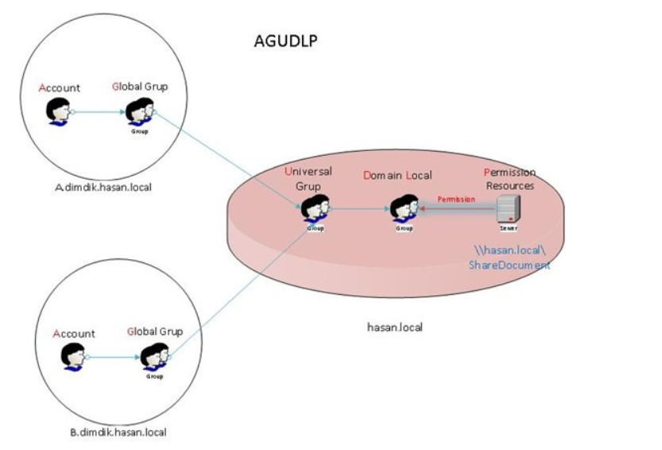

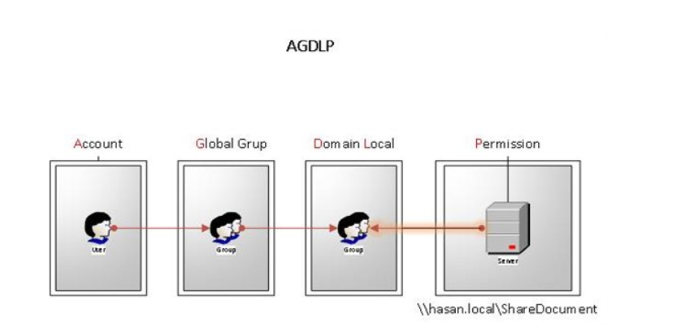

**AD BULK OPERATION**

New-aduser parameters

<https://ss64.com/ps/new-aduser.html>

Import-Csv "C:\userlist.csv" |

foreach

{New-ADuser -Name ($_.FirstName+" "+$_.LastName)

-SamAccountName $_.SamAccountName

-GivenName $_.FirstName

-Surname $_.LastName

-EmployeeID $_.EmployeeID

-Title $_.Title

-City $_.City

-Department $_.Department

-EmailAddress $_.EmailAddress

-OfficePhone $_.OfficePhone

-Path "OU=All users,DC=yigitaydog,DC=local"

-Enable $true

-ChangePasswordAtLogon $true

-AccountPassword (ConvertTo-SecureString -AsPlainText "Password1" -Force)

}

Örnek .csv dosyası

SamAccountName,EmployeeID,Title,City,FirstName,LastName,Department,EmailAddress,OfficePhone

testuser10,1234,baskan,ankara,Abu,Bakar,IT,testuser10@yigitaydog.local,+905056965395

testuser20,3445,koc,istanbul,Kerim,Frei,IT,testuser20@yigitaydog.local,+905359228535

diğer komutlar

New-ADOrganizationalUnit

New-ADGroup

Add-ADGroupMember

Get-ADGroupMember

user rights assignments

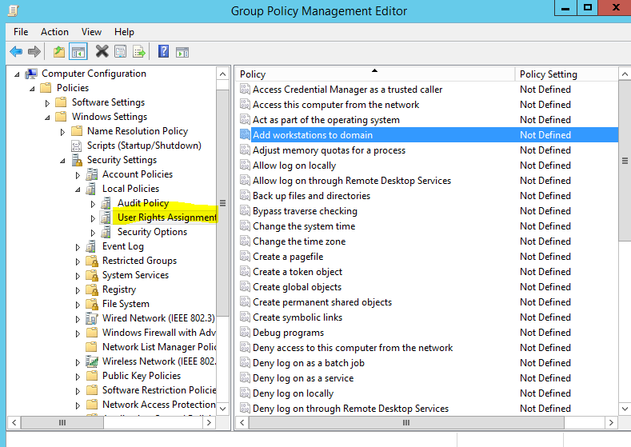

Offline domain join

allows the client machine to join to an Active Directory domain without having network connectivity to that domain

cases:

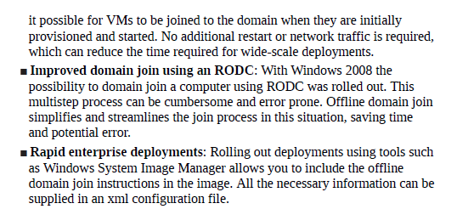

DC üzerinde

djoin /provision /domain yigitaydog.local /machine win10_test /savefile c:\Temp

workgroupta olan win10_test e bu dosya kopyalanır

djoin /requestodj /loadfile c:\Temp /windowspath %systemroot% /localos

Accidental deletion’u kaldırmak

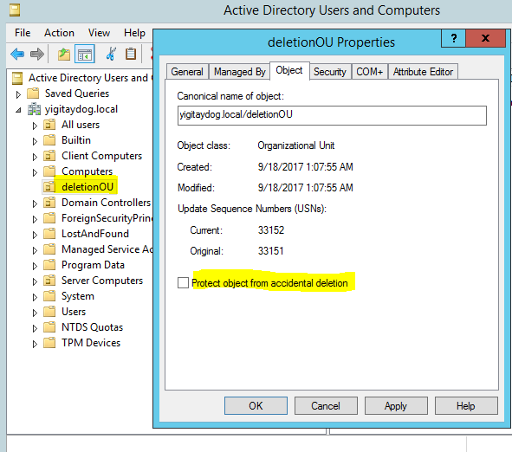

Service Accounts

three built-in service accounts

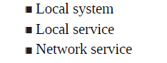

Eğer uygulama servis üzerinden çalışacaksa

Creating dummy service



Virtual service account (şifresi otomatik sistem tarafından verilir)

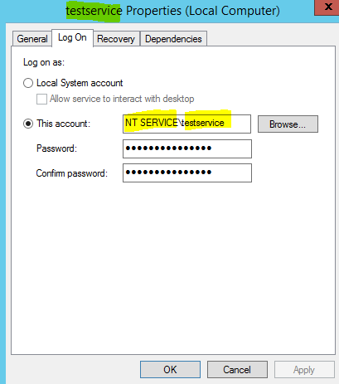

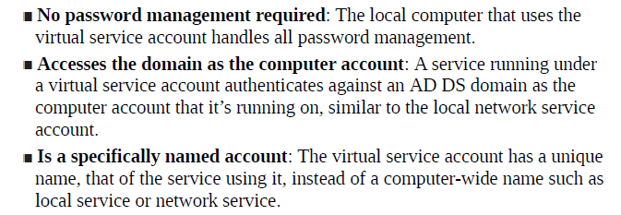

~~Regular service account~~

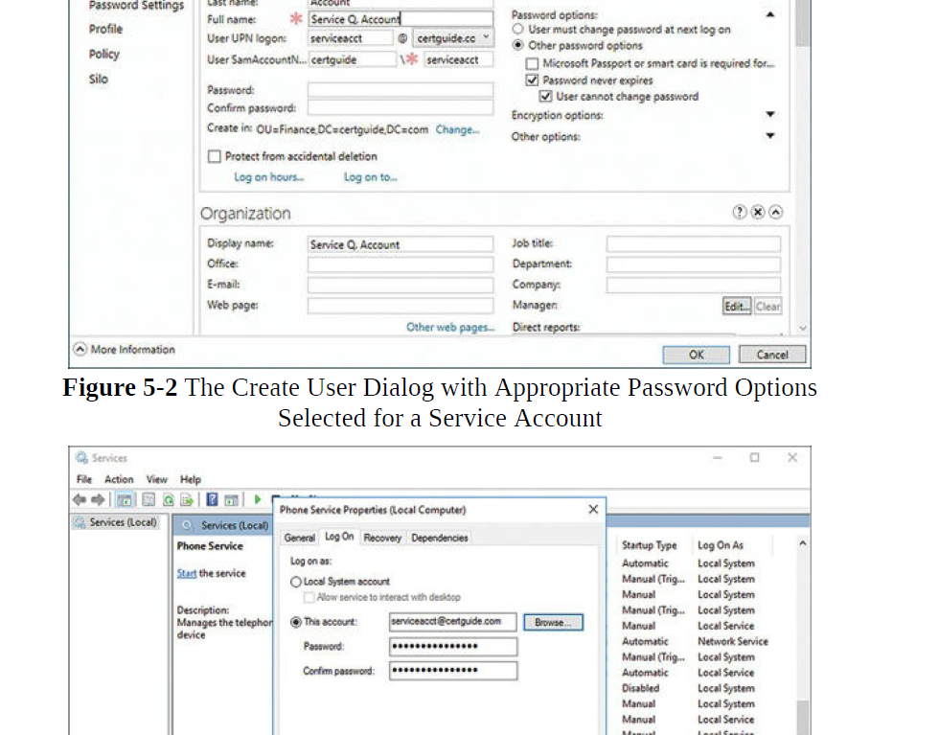

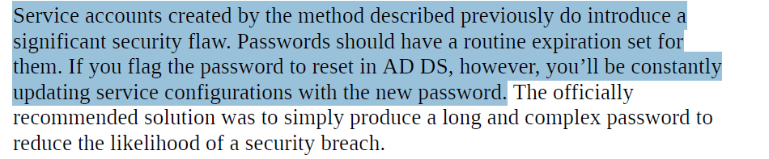

Managed system account

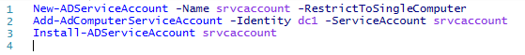

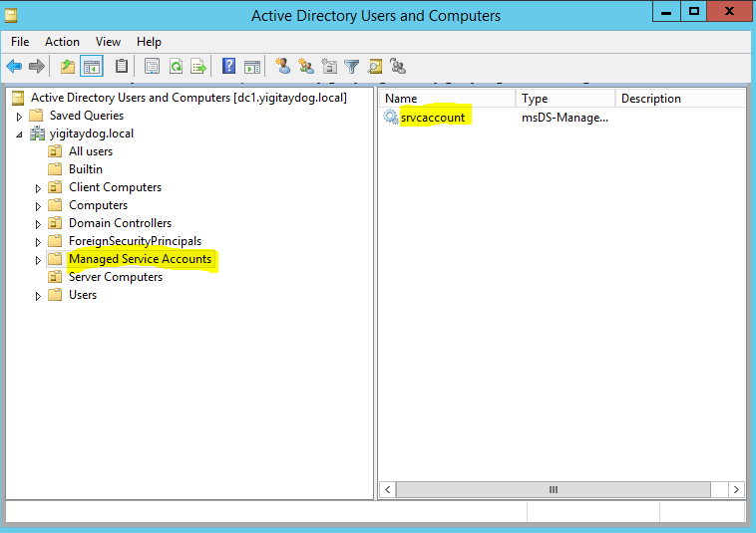

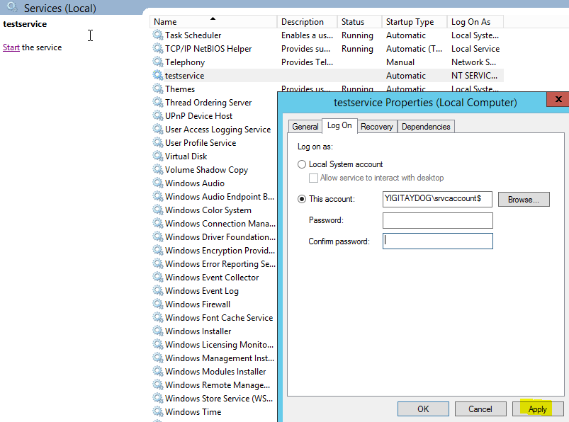

Şifresi olmaz

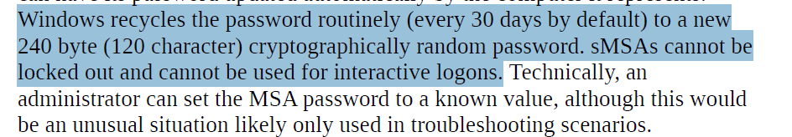

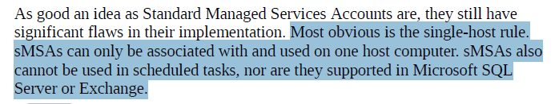

Group managed system account

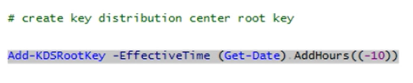



On other computer (APP-NUG)

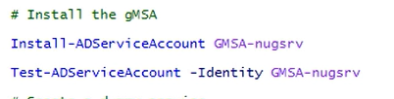

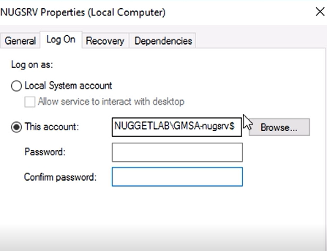

Service Principal Account (SPN)



Pointer info so that client or another machine needs to access a service there can be nice association between that service and the other services might on the system and service account that can be configured to run that service

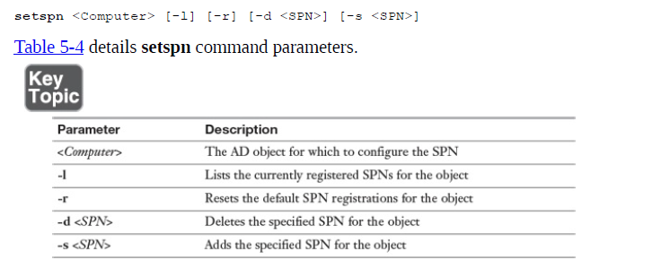

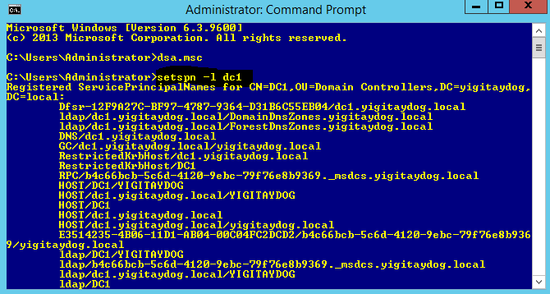

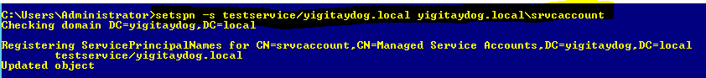

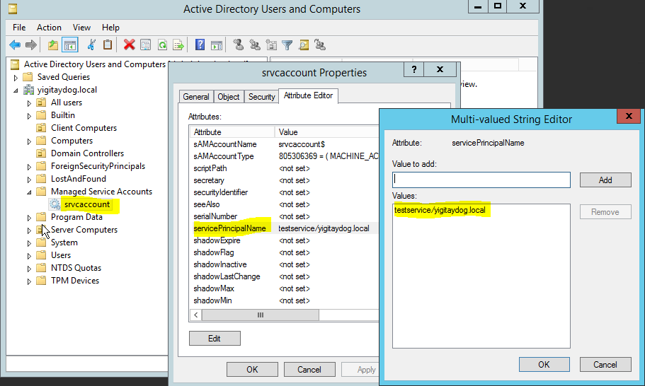

Kerberos Constrained Delegation (KCD)

allowing one application or service to delegate authentication to another service

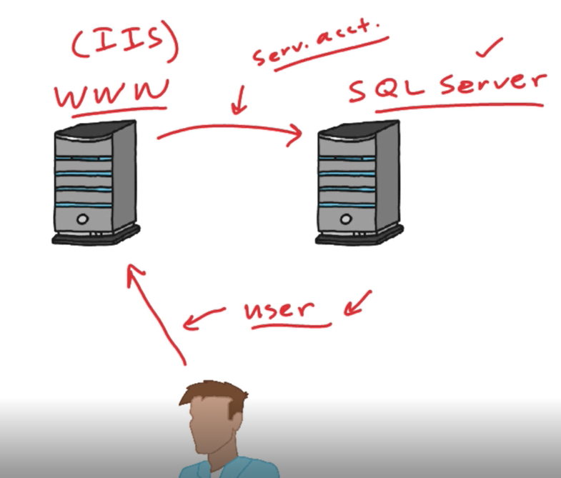

Servis account’u yerine kullanıcı hesap şifreleri kullanmak

DC üzerinde eklenmesi

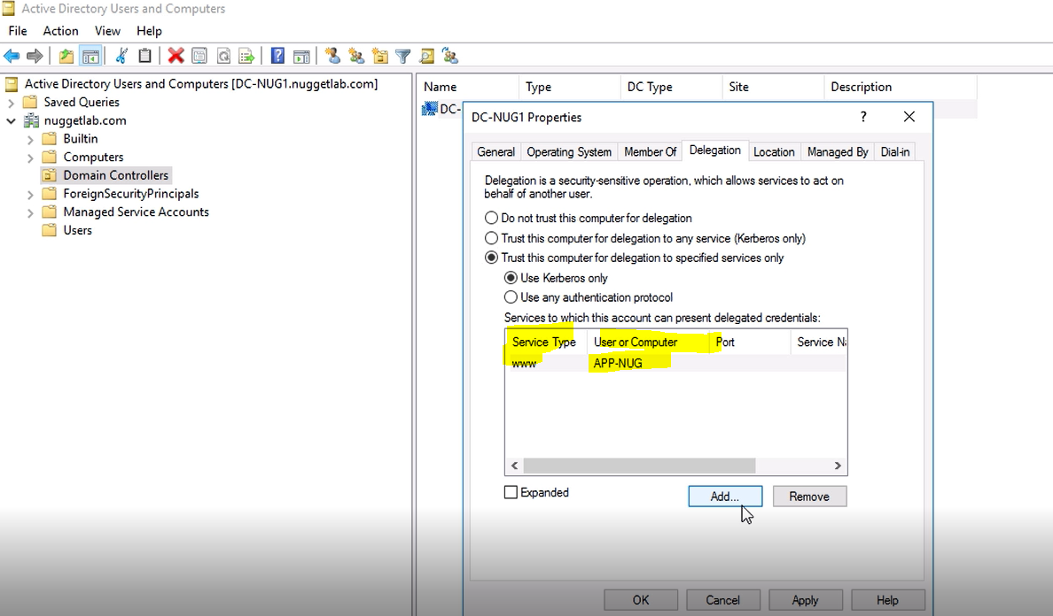

**domain and local user password policy settings**

local sistemde >> secpol.msc üzerinden görülebilir

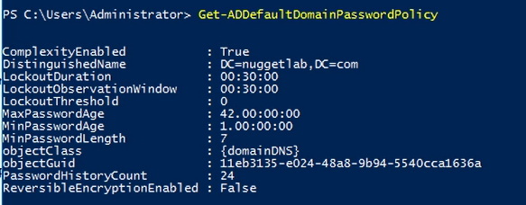

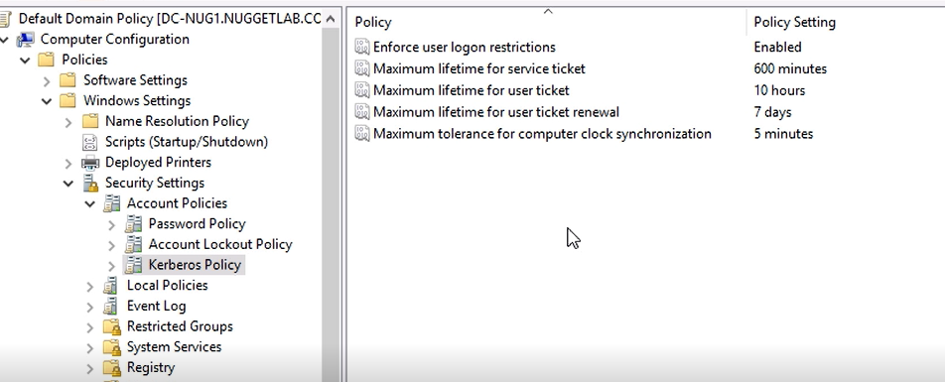

Kullanıcılar için özel şifre oluşturmak

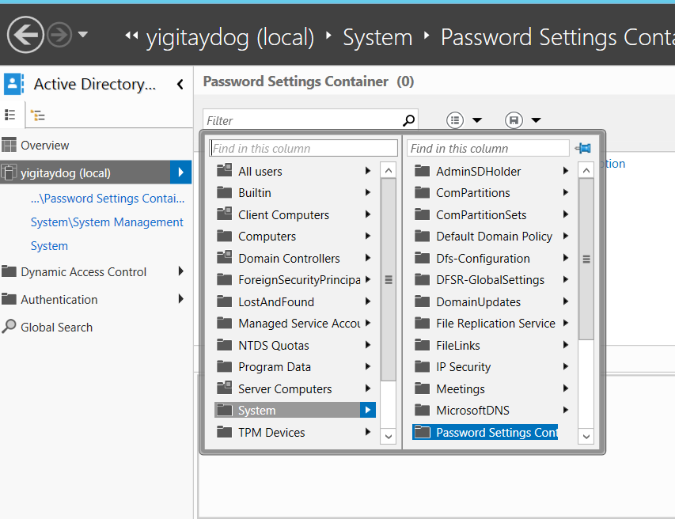

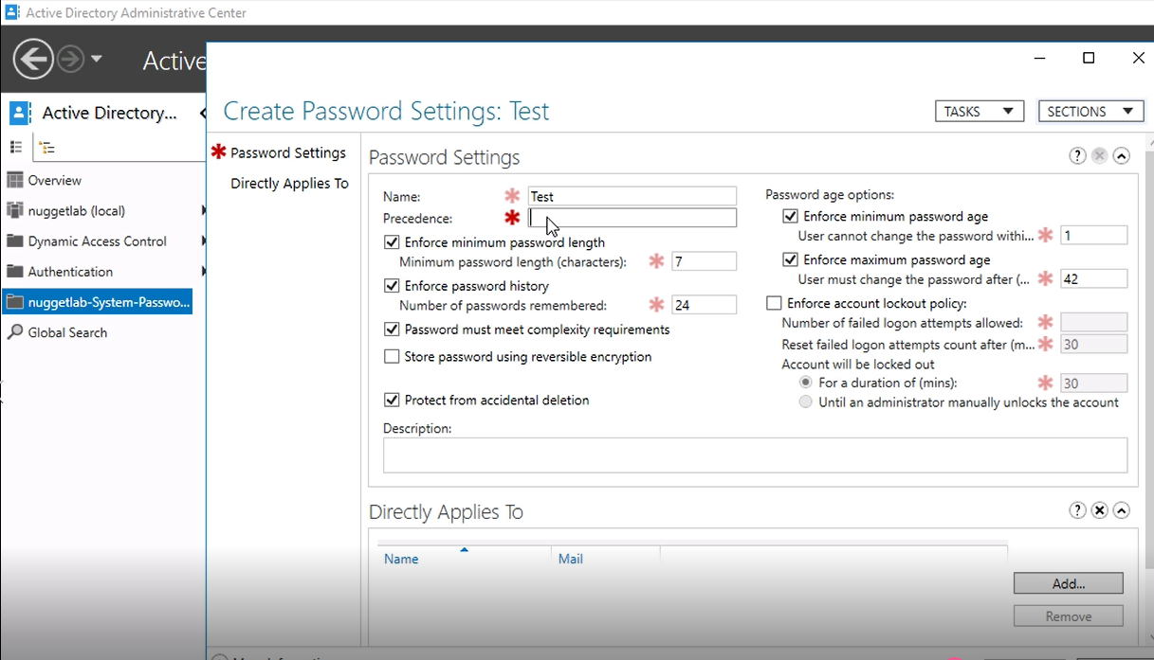

delegate password settings management

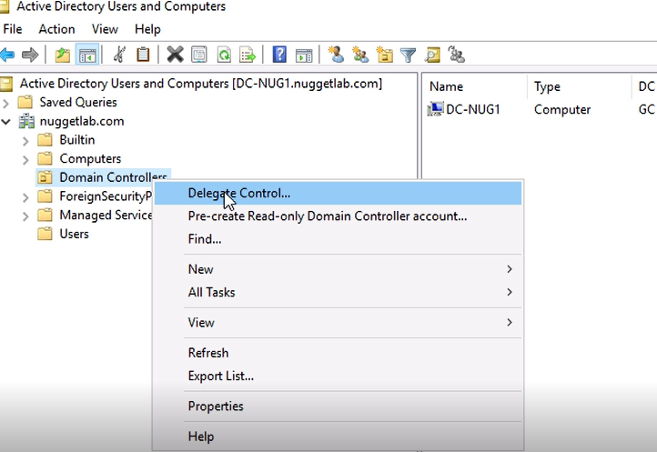

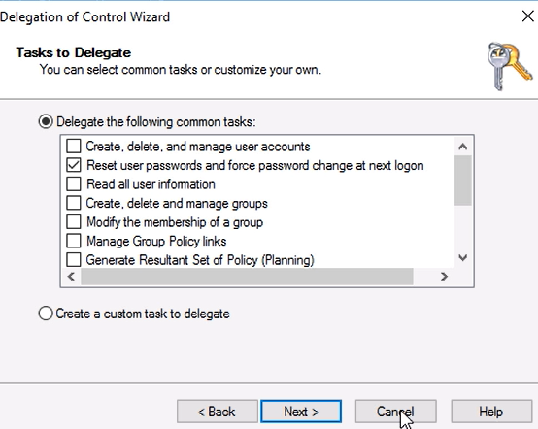

OFFLINE AD (Directory Services Restore Mode DSRM)

Stop service

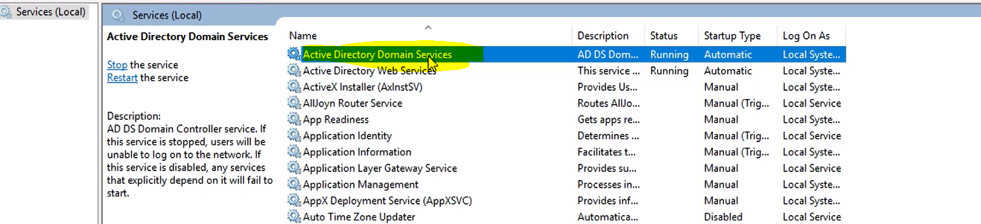

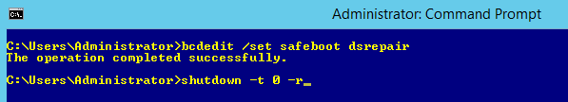

Reboot sonrası

Maintenance için local admin olarak sisteme girilir (DSRM password’u ile)

DSRM mod’da gerekli bakım yapılır

Safemod’dan çıkmak için

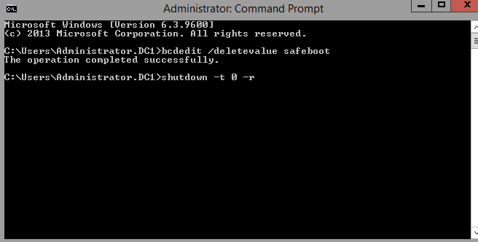

offline defragmentation of an Active Directory database

Periodically performing an offline defragmentation is a great way to get some of your domain controller’s disk space back

>ntdsutil

ntdsutil: activate instance ntds

ntdsutil: files

file maintenance: compact to c:\

file maintenance: integrity

file maintenance: quit

ntdsutil: quit

>copy c:\ntds.dit c:\windows\ntds\ntds.dit

Overwrite > YES

>del c:\wndows\ntds\*.log (deleting old log files)

Removing DC and Clean-up Metadata

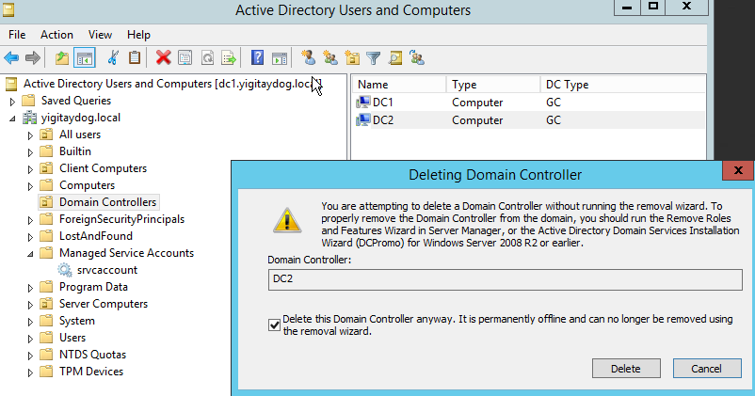

Silinecek DC’de fsmo roller varsa silinmeden önce taşınmalıdır!

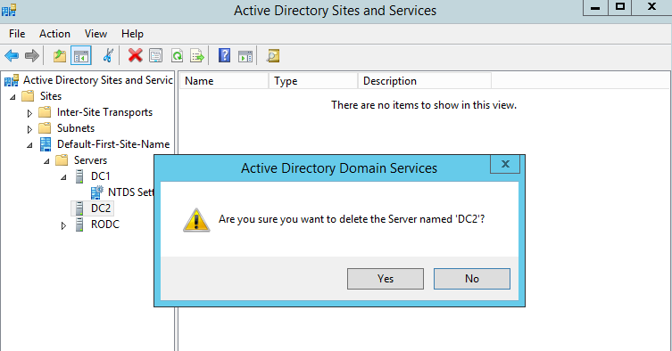

Backup and Restore Active Directory

Enabling recycle bin

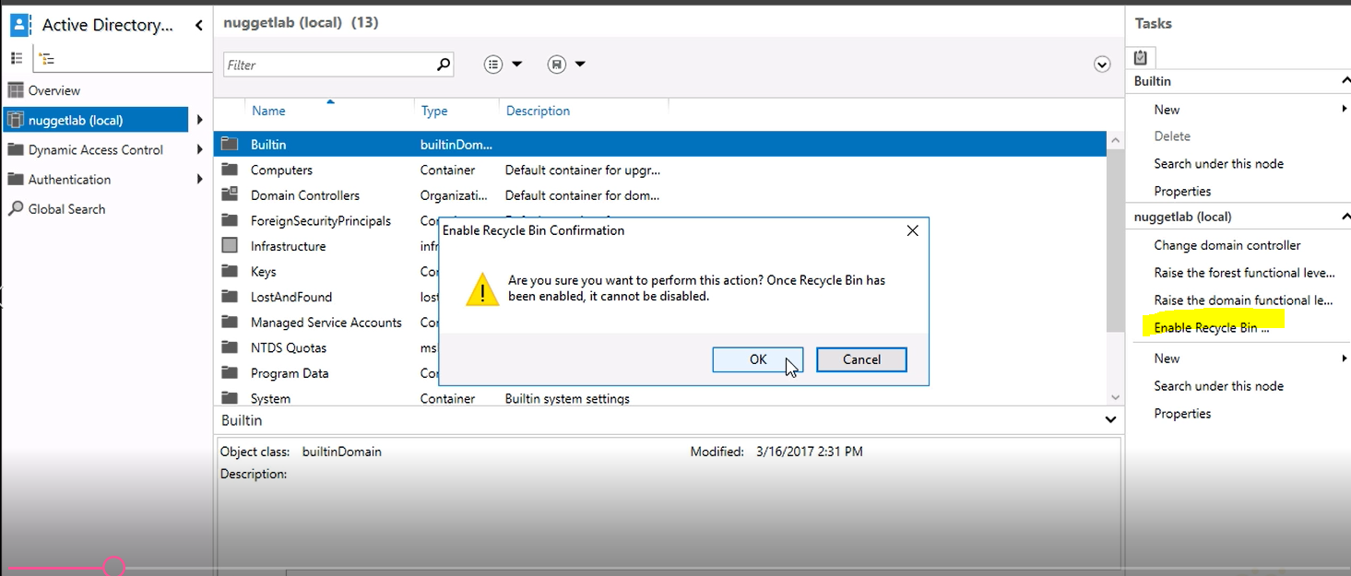

Silinen objeler

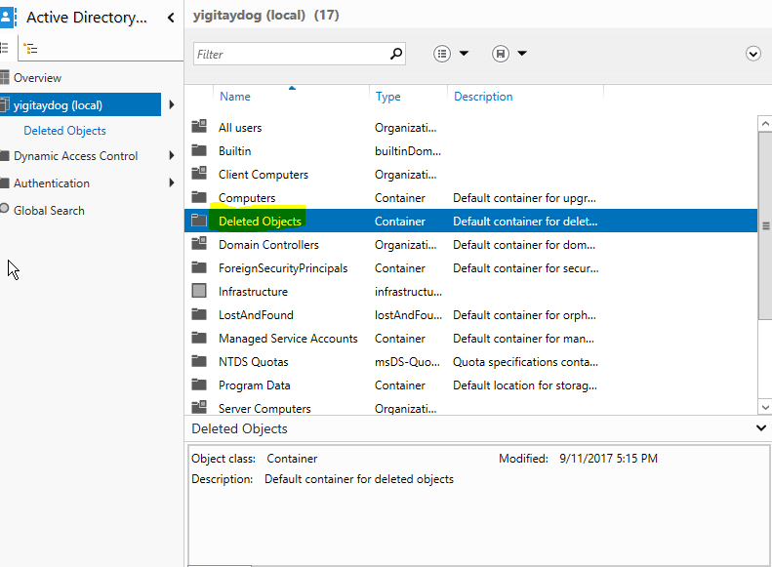

Deleted object kabından “restore” edilebilir

180 gün silinen objeler burada tutulur

**configure Active Directory snapshots**

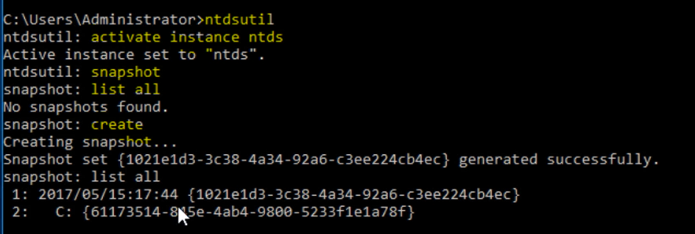

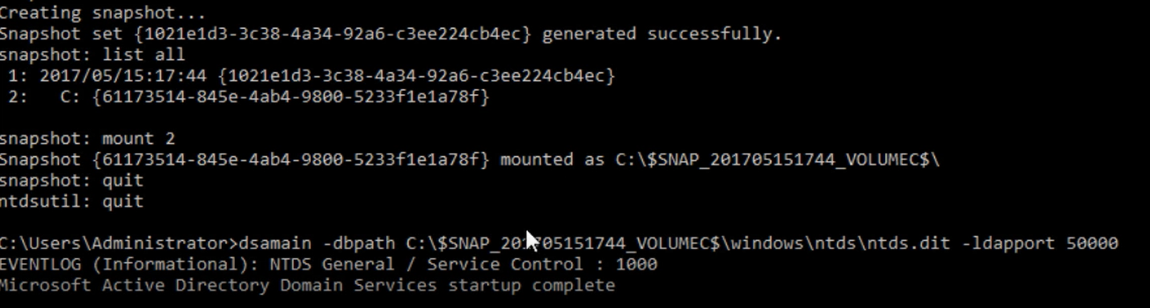

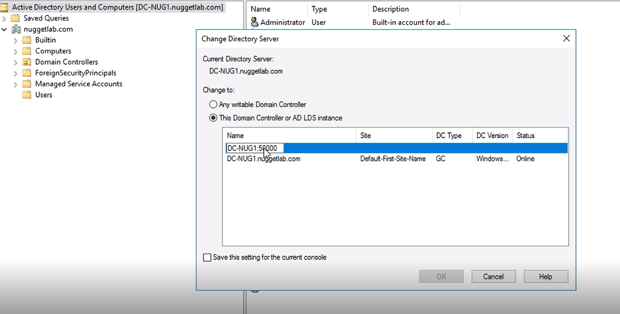

Unmount etmek

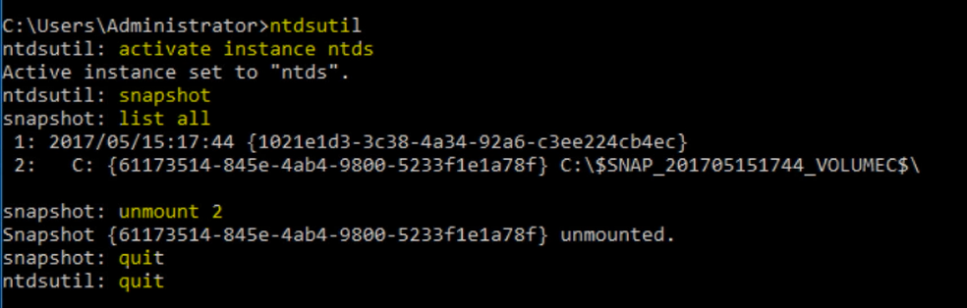

Backup & Restore

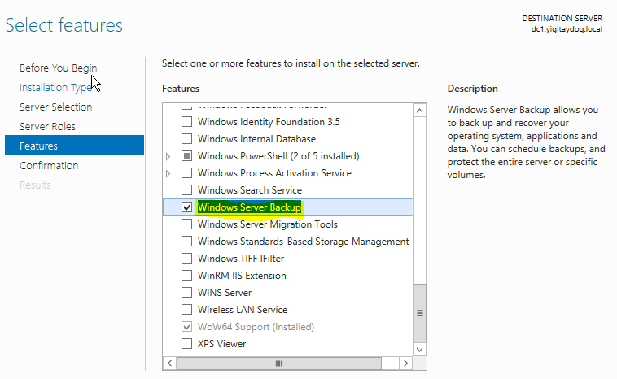

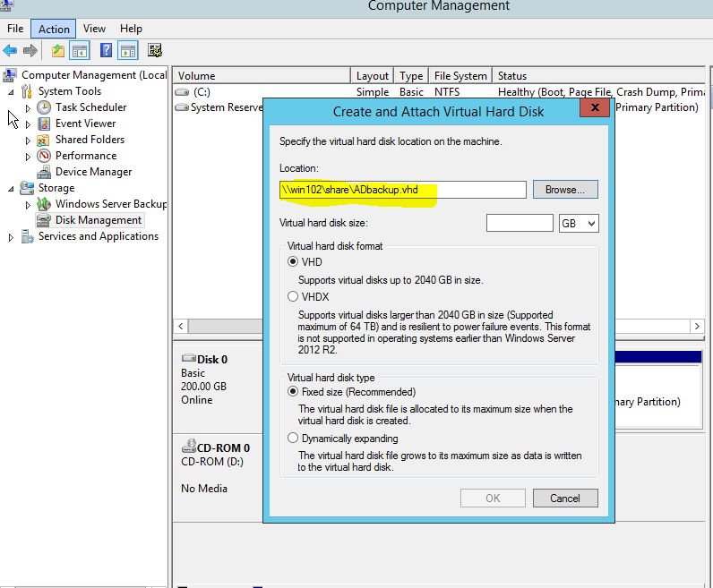

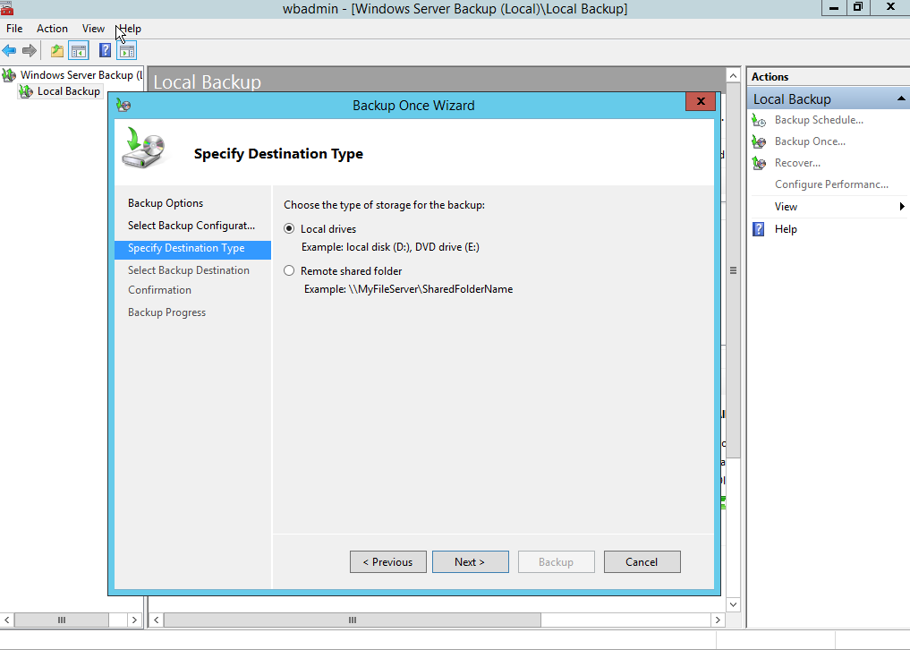

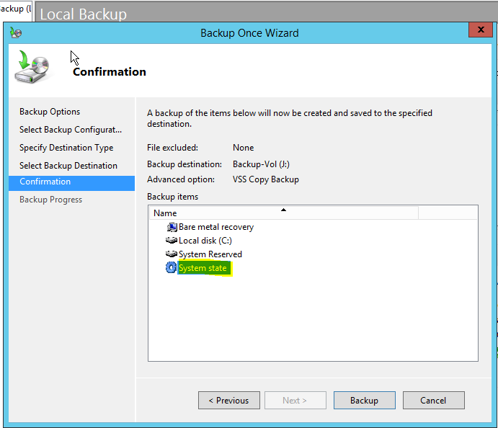

Back-up bitince DSRM moduna girilir

Back up konsoluna girilir, alınan back up bulunur

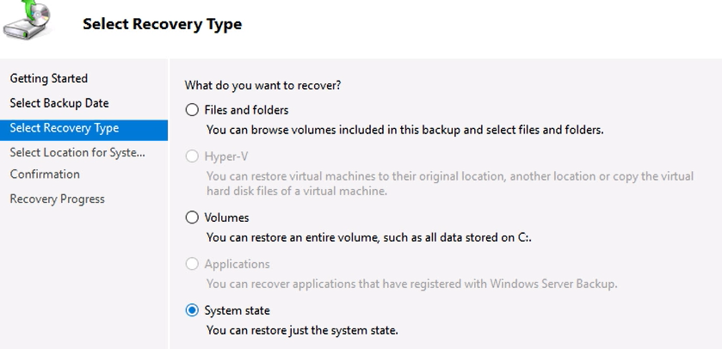

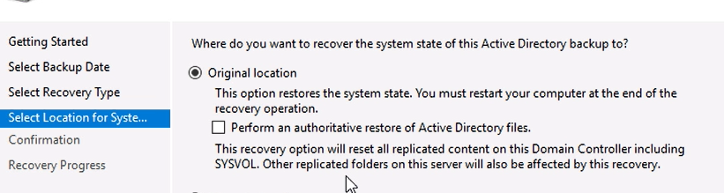

Recover’a basilır, işlem bitince DSRM modundan çıkılır ve restart edilir

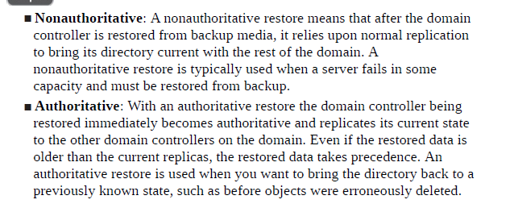

Replication of Active Directory

Karşı dc’de

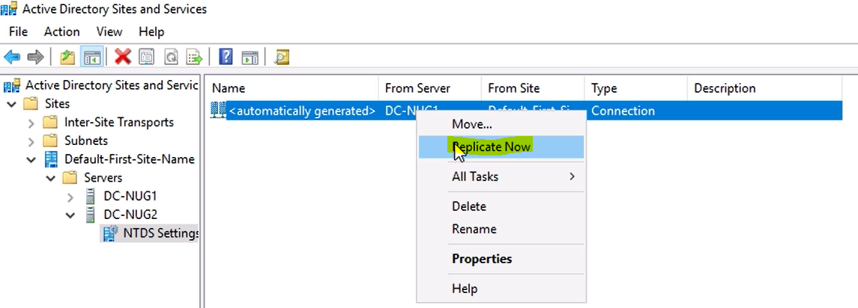

SYSVOL DFS Replication servisi ile gerçekleşir



RODC Password Replication Policy (PRP)

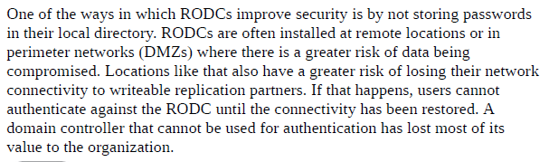

When user authenticate to RODC, it checks password info from non read only DC

No cache of user password on RODC

RODC üzerinde şifreleri cache’lenmesi istenen kullanıcılar>> “Allowed RODC Password Replication Group”

RODC üzerinde şifreleri cache’lenmemesi istenen kullanıcılar>> “Denied RODC Password Replication Group”

RODC üzerinde

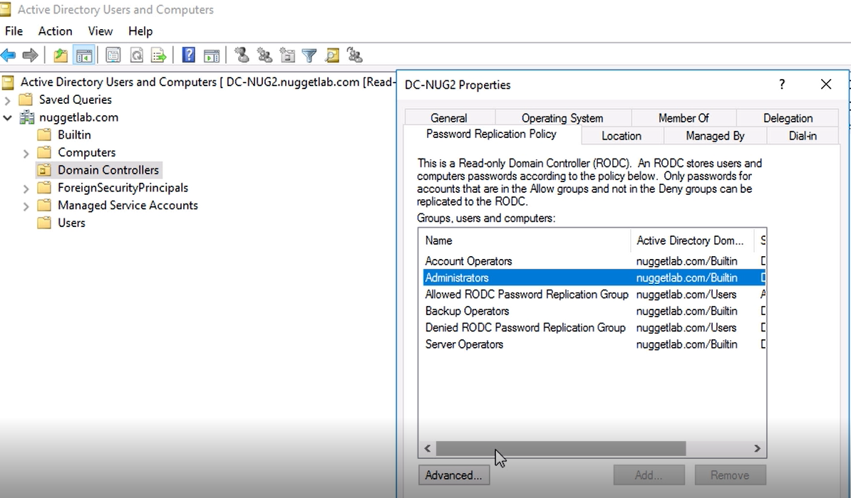

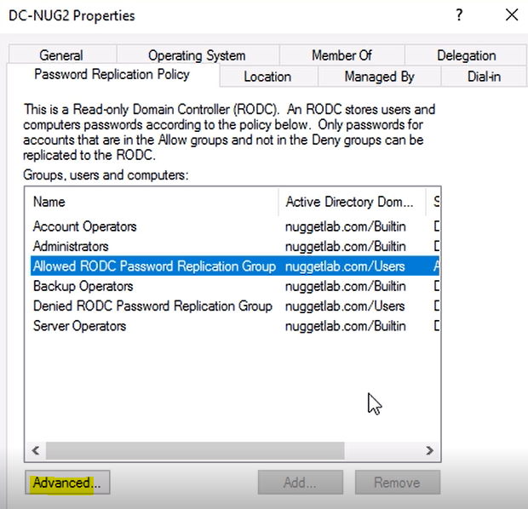

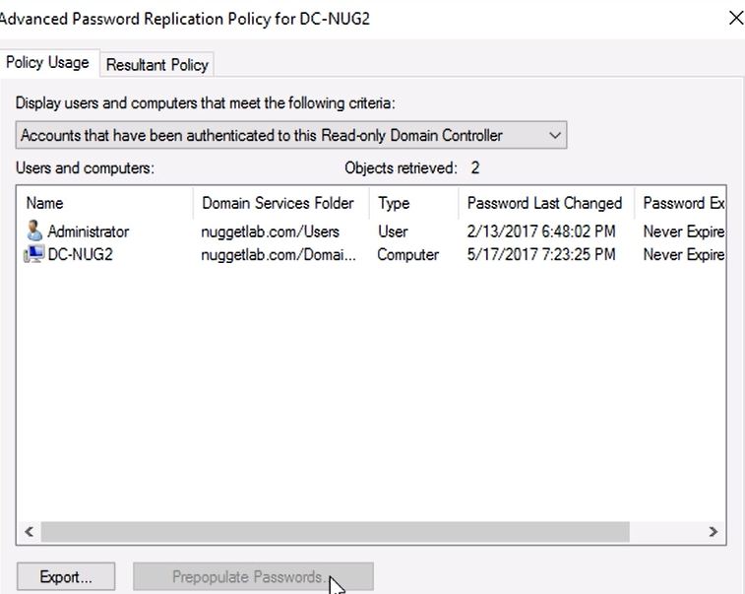

**Monitoring and managing replication**

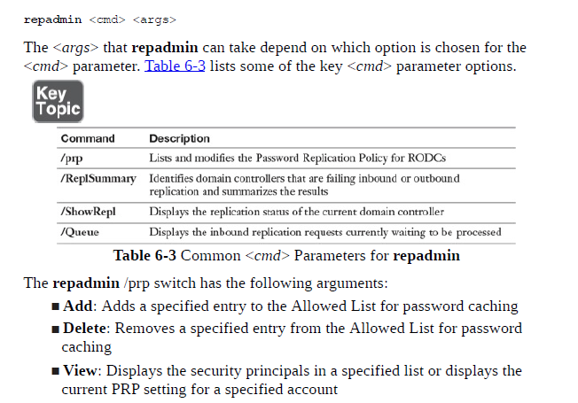

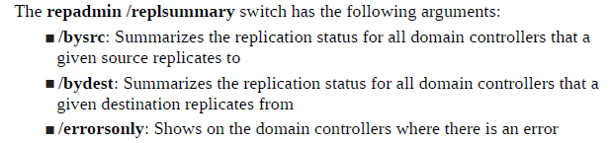

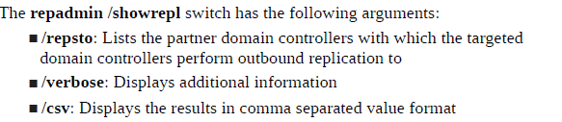

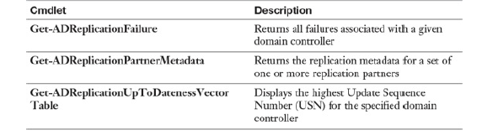

**DOMAIN AND FOREST SETTINGS**

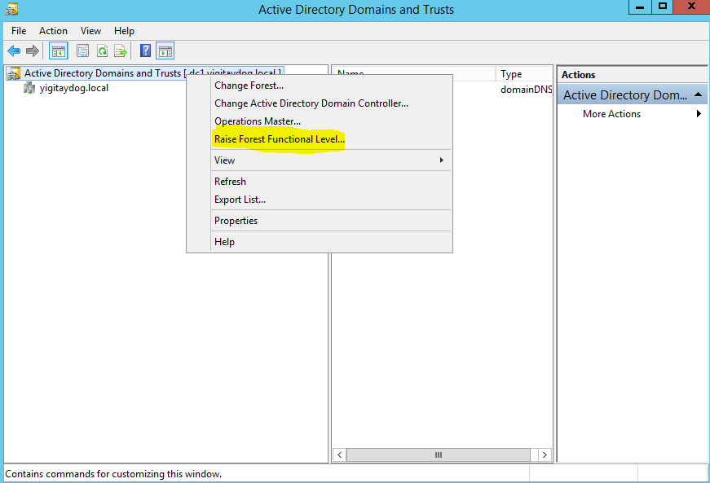

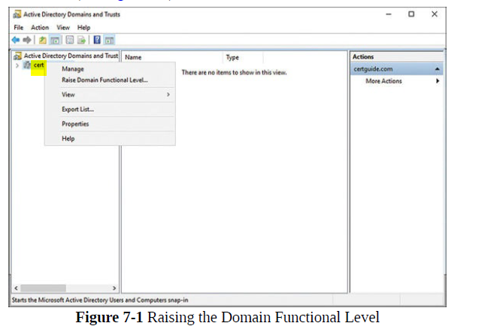

*domain functional level can go higher than forest level*

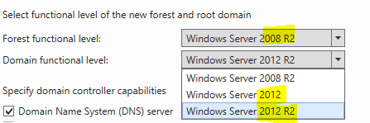

*Domain functional level cannot be lower than forest functional level

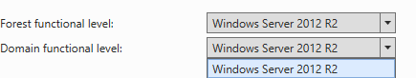

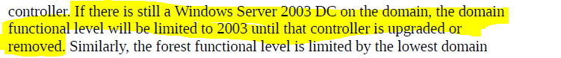

Adding UPN Suffix



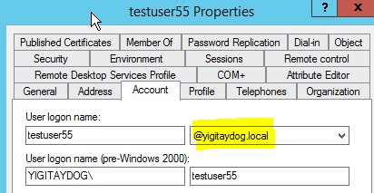

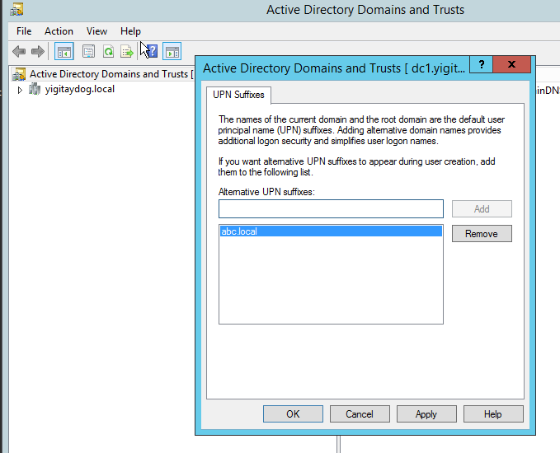

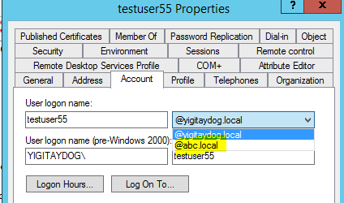

Trust Types

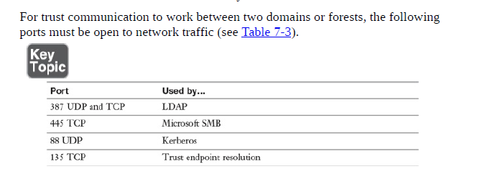

NT 4.0 type server-regular server >> external trust

Non Kerberos server-regular server >>Realm trust

Iki farklı forest regular server >> forest trust

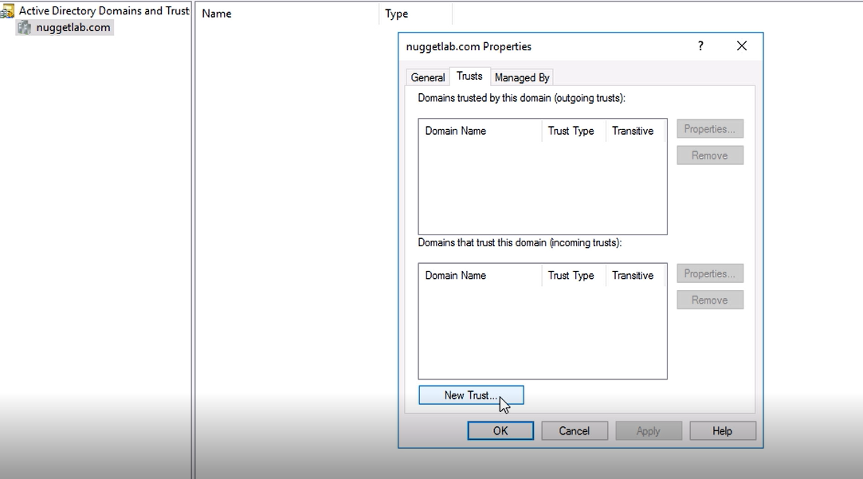

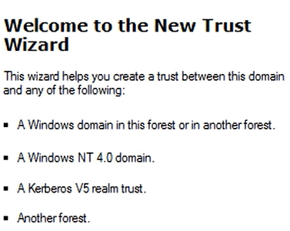

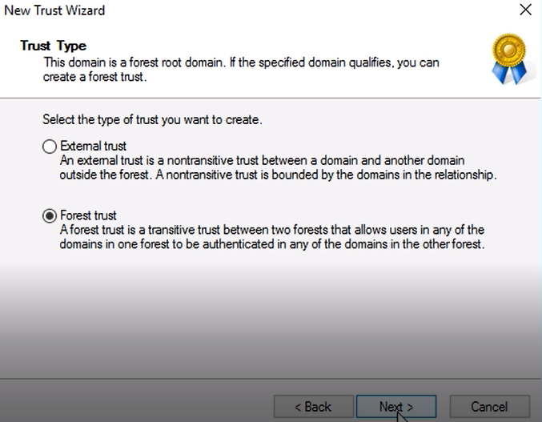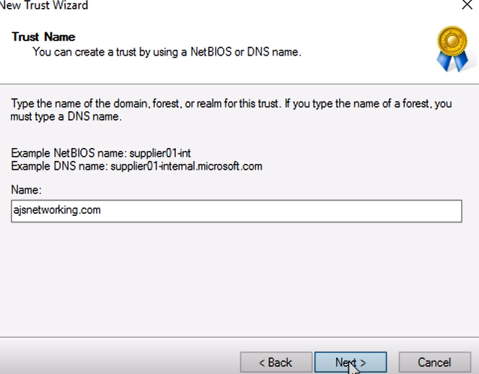Nuggetlab.com ile ajsnetworking.com ‘un trust ilişkisinin kurulması (Nuggetlab DC si üzerindeyken)

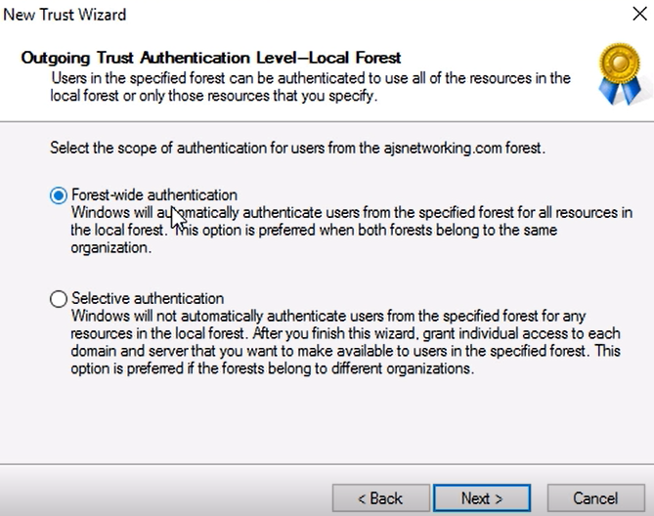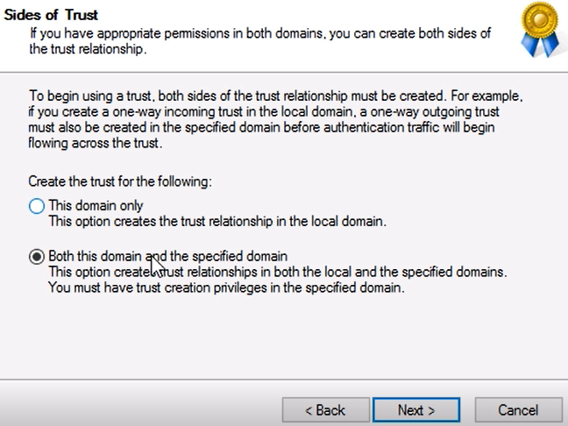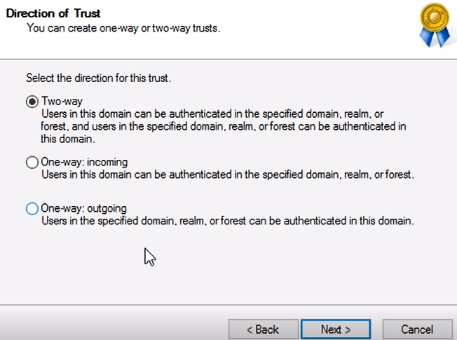

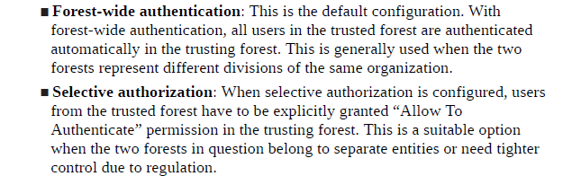

Selective Authentication >> SID Filtering

name suffix routing>>



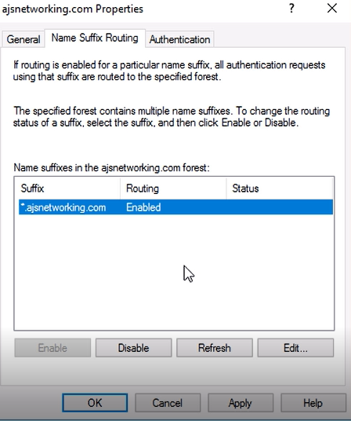

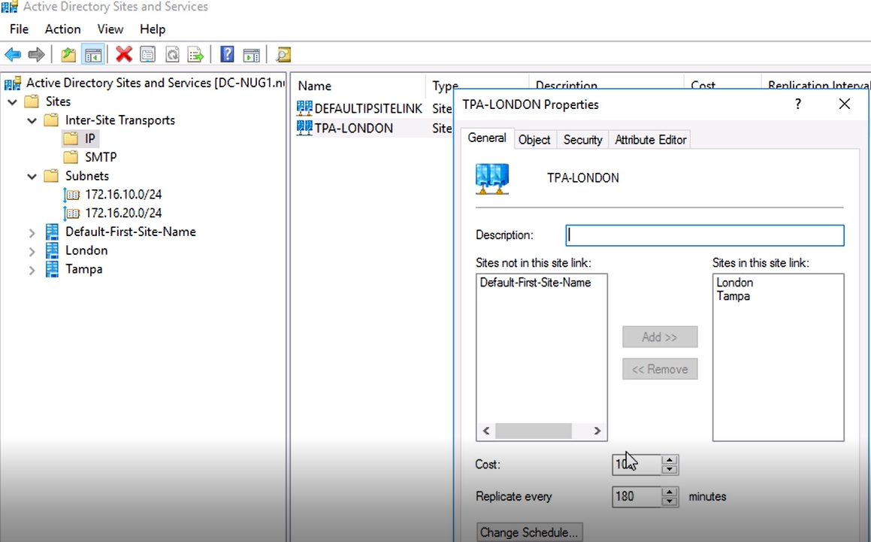

Lower cost are better, which link is used most frequently

Client’lar doğru DC’leri nası bulur

SRV records or RODC or adding that subnet to site

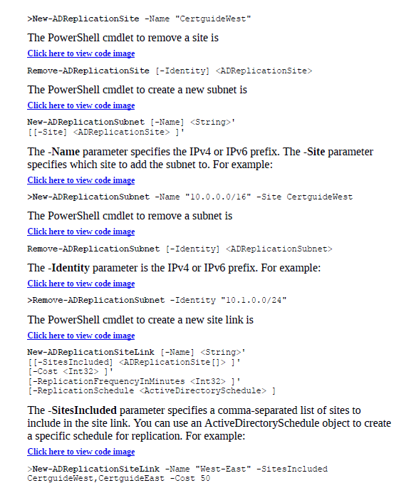

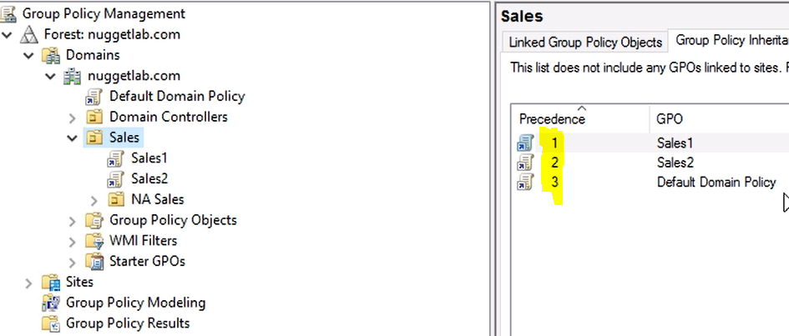

Loopback Processing Mode

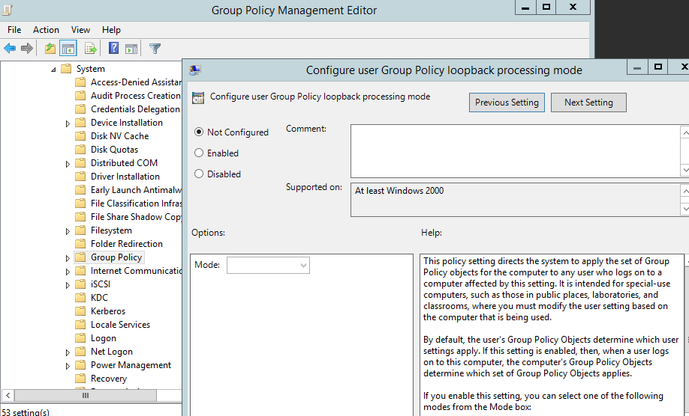

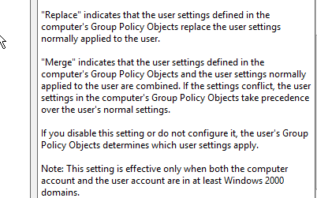

Slow link GPO processing settings



Backup and restore GPO

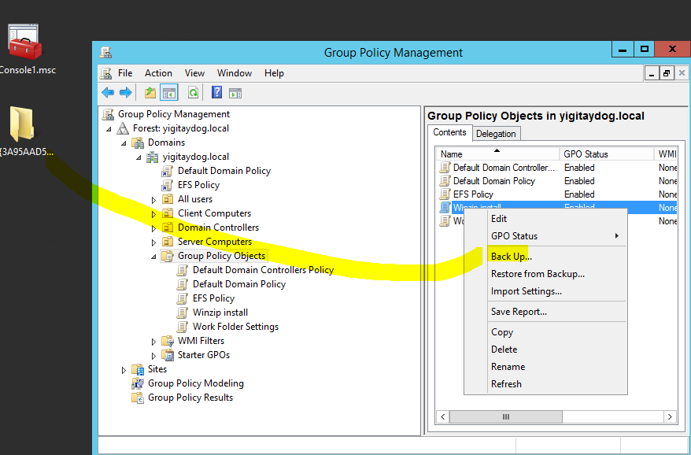

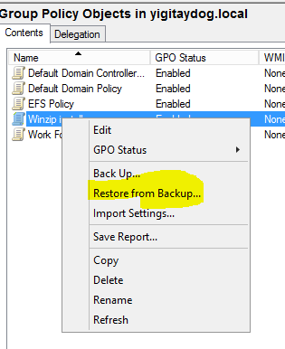

reset default GPOs

dcgpofix /Target: domainname

detect health issues using the Group Policy Infrastructure Status

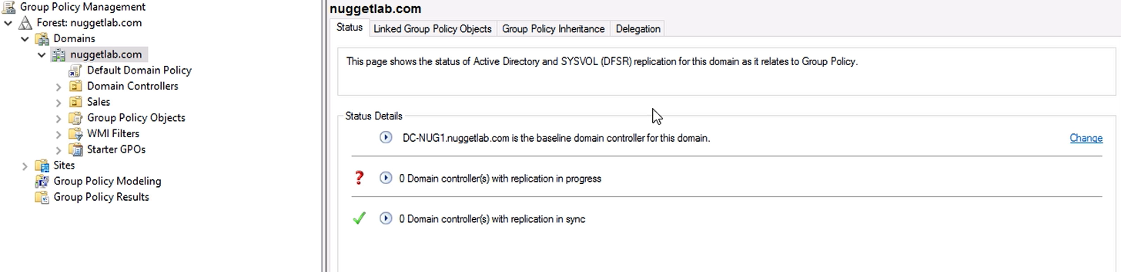

Delegation

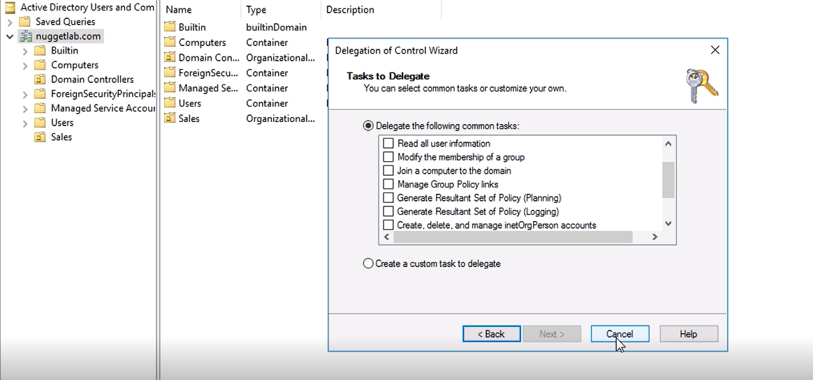

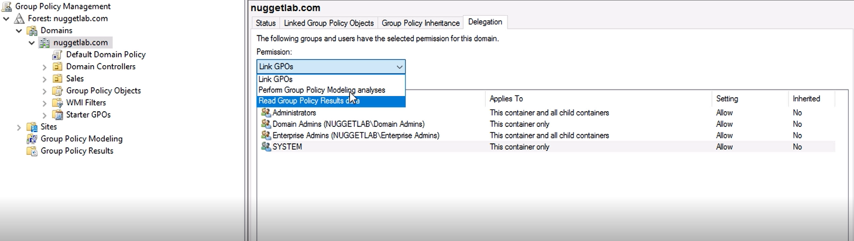

Configure processing order and precedence

Aynı ou ya uygulanan gpodaki Conflict > link order’I düşük olan basar

Enforce üstte olursa inheritance nın etkisi kalmaz

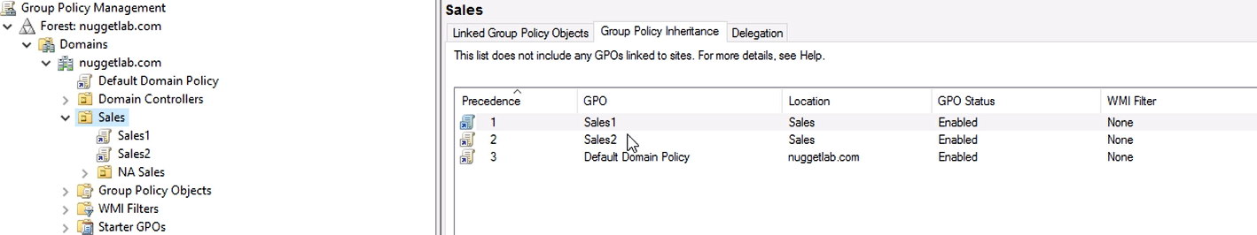

Security Filtering

Sadece belli kullanıcılara etki etsin yada etmesin ayarı

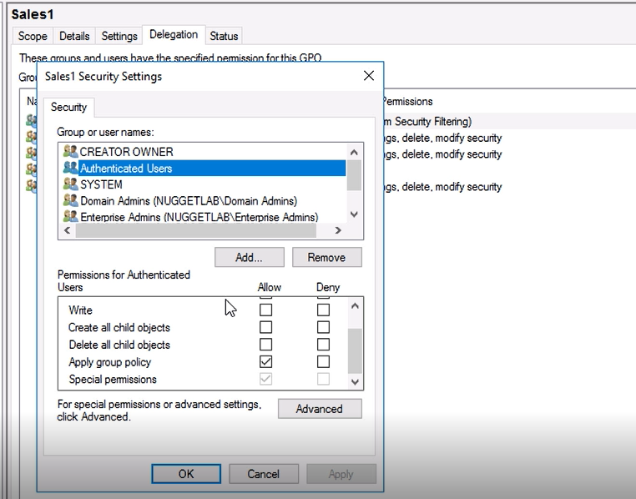

Read and apply group policy tikleri deny’a çekilip gpo nun uygulanmasını istediğimiz kullanıcıya allow’ları vermek

Loopback processing mode 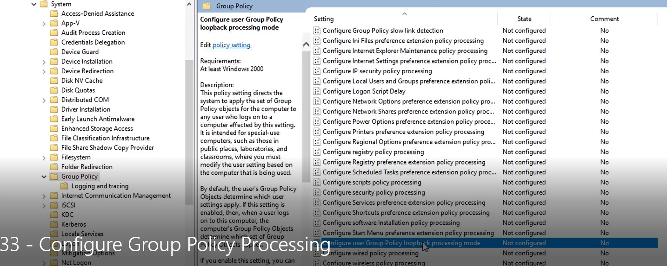

Slow-link and caching

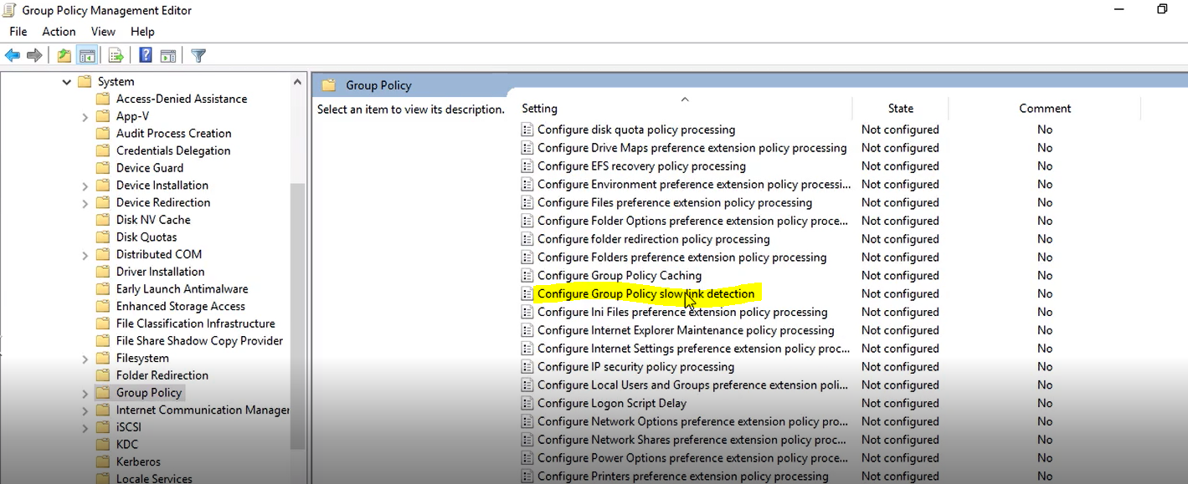

Enable

Transfer hızı Threshold dan dusuk ise gpo’lardan sadece kritik olanlar işlenir

Configure group policy caching>Transfer hızı Threshold dan dusuk ise gpo’lardan cache de olanlar işlenir

GPODan software installation

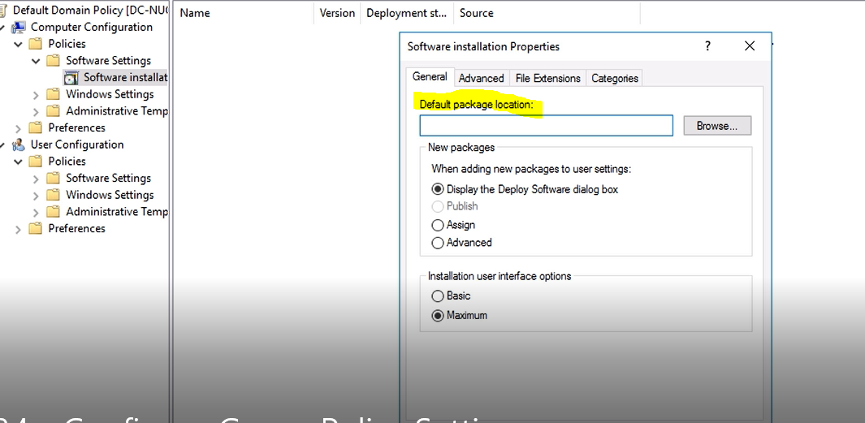

Package location netwok share olmalı (.msi)

,

Security Template’lerinin GPO’ya yüklenmesi

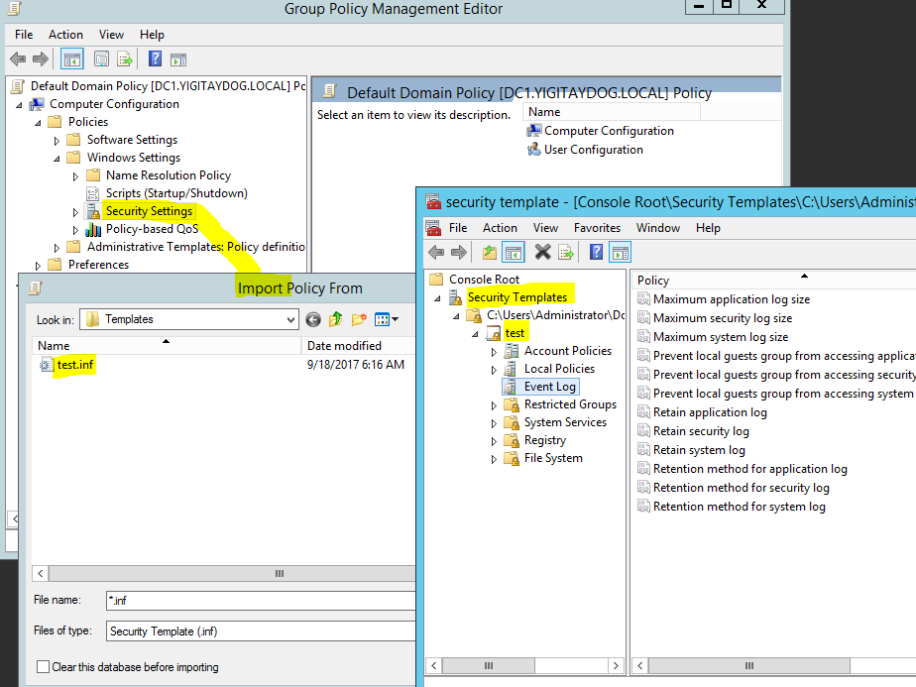

Policy Template’lerinin merkezileştirilmesi

Bu işlem yapılmadan önce:

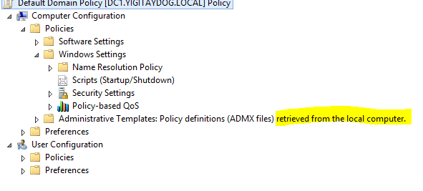

**Configuring central store**

DC üzerindeki

C:\Windows\PolicyDefinitions ‘un

C:\Windows\sysvol\”domainname”\Policies altına cut and paste

Bu işlem yapıldıktan sonra

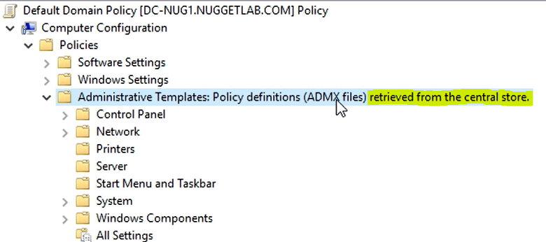

Property filters for administrative templates

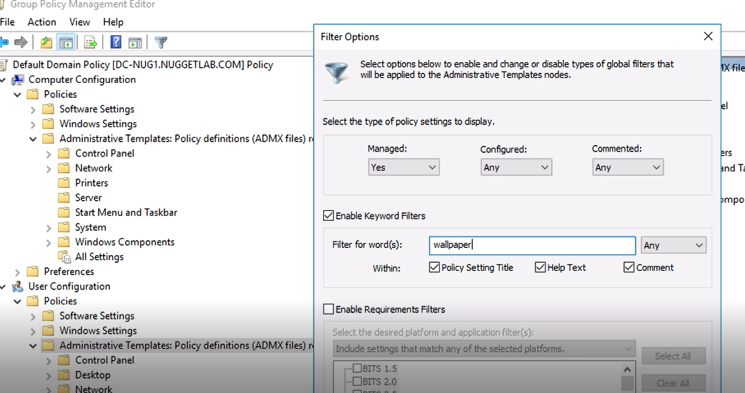

import a custom administrative template file

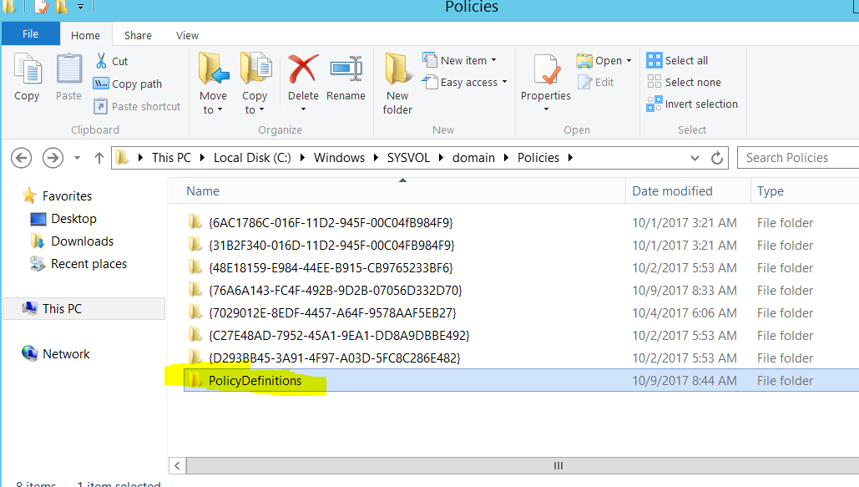

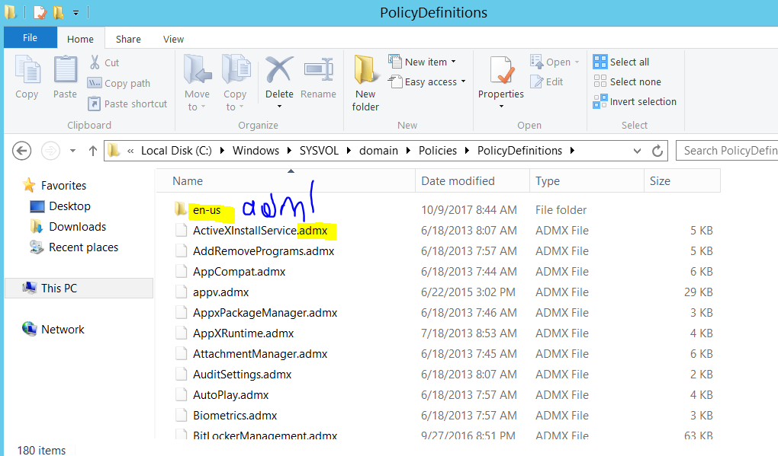

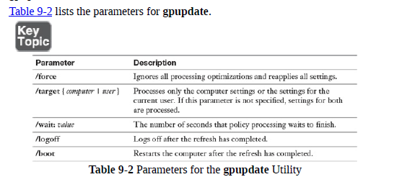

remotely force a policy refresh

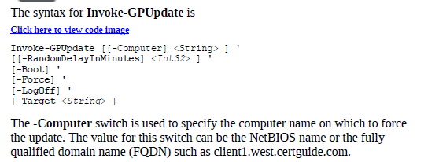

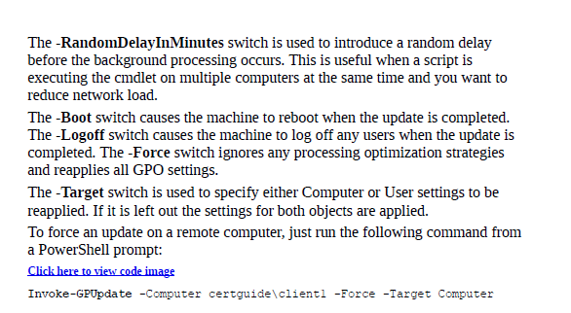

Group Policy Preferences

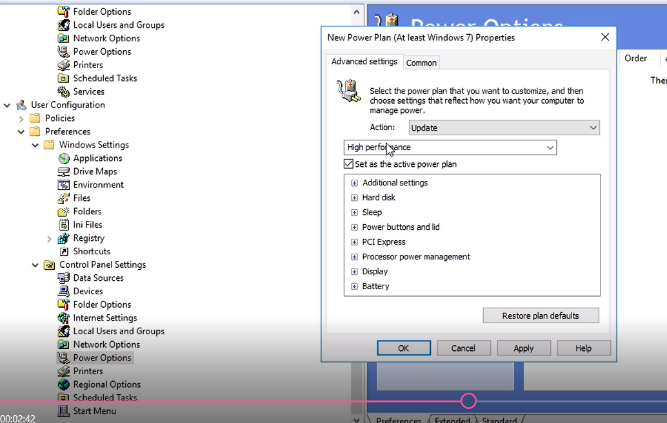

Internet settings,regional options,start menu preferences exclusive to user configuration portion of GPO. Services preference are only available via Computer configuration.

**automate unlocking of disabled accounts**

disabling user account  
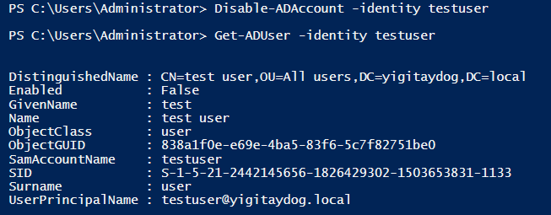

enabling user account

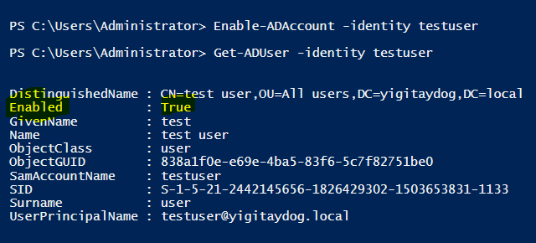

Disables all accounts in an OU:

PS C:\> Get-ADUser -Filter 'Name -like "*"' -SearchBase "OU=RemoteAccounts,DC=SS64,DC=COM" | Disable-ADAccount

Searching for disabled users

Search-ADAccount –AccountDisabled

Search-ADAccount –AccountDisabled –UsersOnly

**automate password resets using Windows PowerShell**

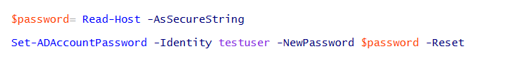

**CERTIFICATION AUTHORITY**

All computers that are members of the same forest as the enterprise CA automatically trust certificates issued by the CA.

recommends an offline standalone root CA with enterprise subordinate CAs in most deployments. This arrangement allows the signing CA (the root) to remain offline most of the time and limit its exposure to potential security issues.

Enterprise root CAs are also expected to be unique in a forest, meaning that it is not recommended to have more than one.

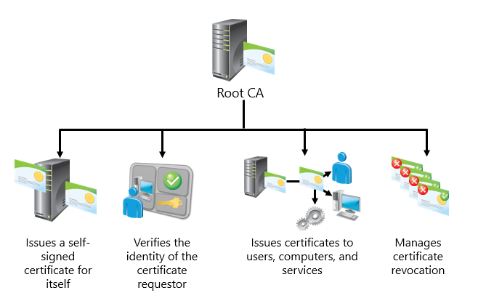

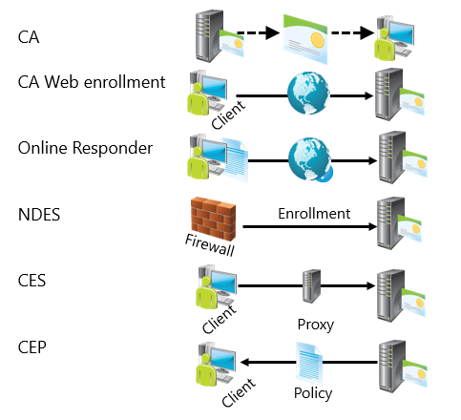

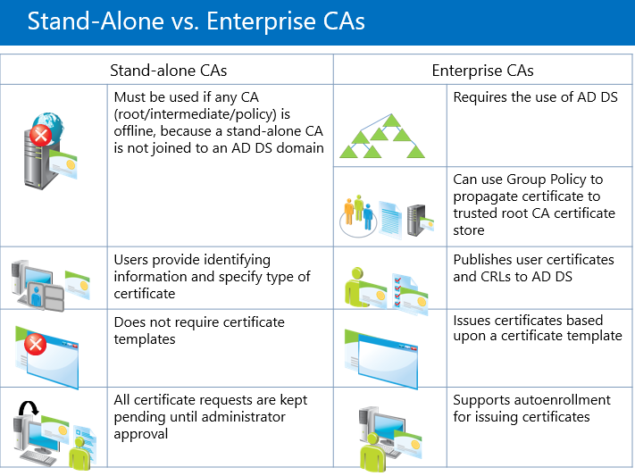

**Certification authorities (CAs)**. A CA accepts a certificate request, verifies the requester's information according to the policy of the CA, and then uses its private key to sign the certificate. The CA then issues the certificate to the subject of the certificate for use as a security credential within a PKI. A CA is also responsible for revoking certificates and publishing a certificate revocation list (CRL).

 A certificate that is issued by a CA to itself is referred to as a trusted root certificate

**Install Active Directory Integrated Enterprise Certificate Authority (CA)** OK

**Install Subordinate CA**

ROOT CA üzerinde

Certificate Revocation List (CRL) distribution points

 CRLs are complete, digitally signed lists of unexpired certificates that have been revoked. This CRL is retrieved by clients who can then cache the CRL (based on the configured lifetime of the CRL) and use it to verify certificates presented for use.

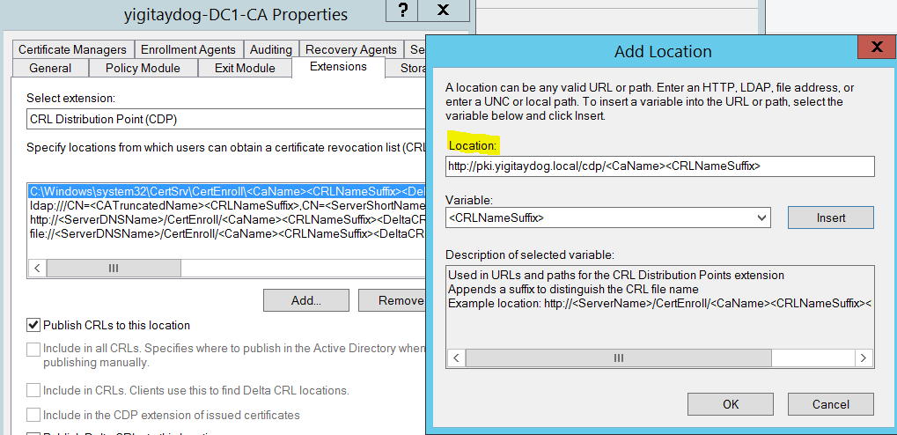



CRL distribution points>> The purpose of the CRL is to list certificates which are valid, but are revoked.

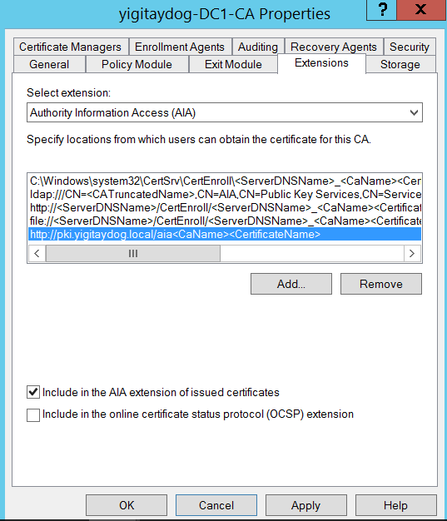

Authority Information Access (AIA) >> Authority information access locations are URLs that are added to a certificate in its authority information access extension. These URLs can be used by an application or service to retrieve the issuing CA certificate.

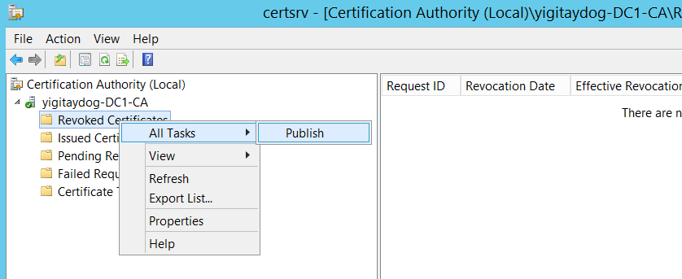

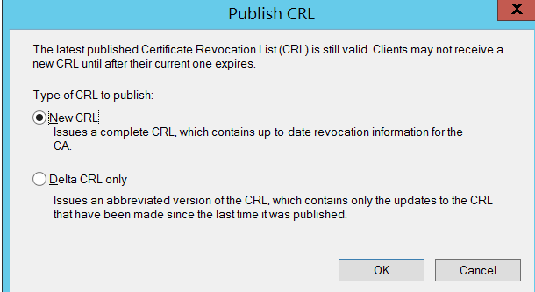

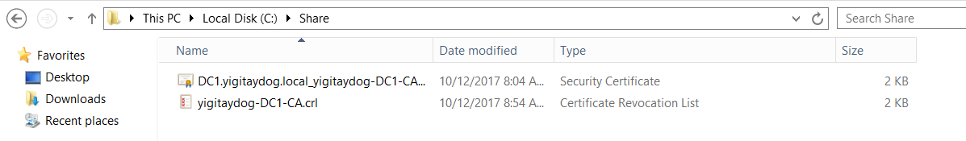

**Standalone SUBCA**

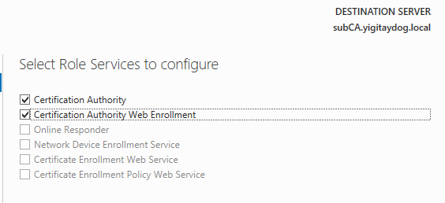

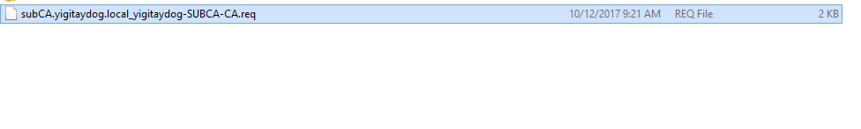

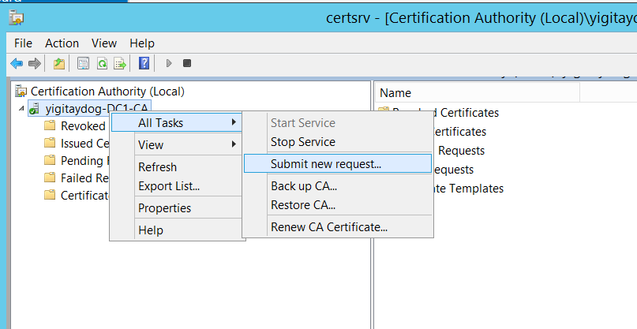

Use .req file

İssued cert’i 

Sub CA de install et trusted root cert e ekle

For an offline CA, choose to install it as a standalone CA

**manage certificate enrollment using Group Policies**

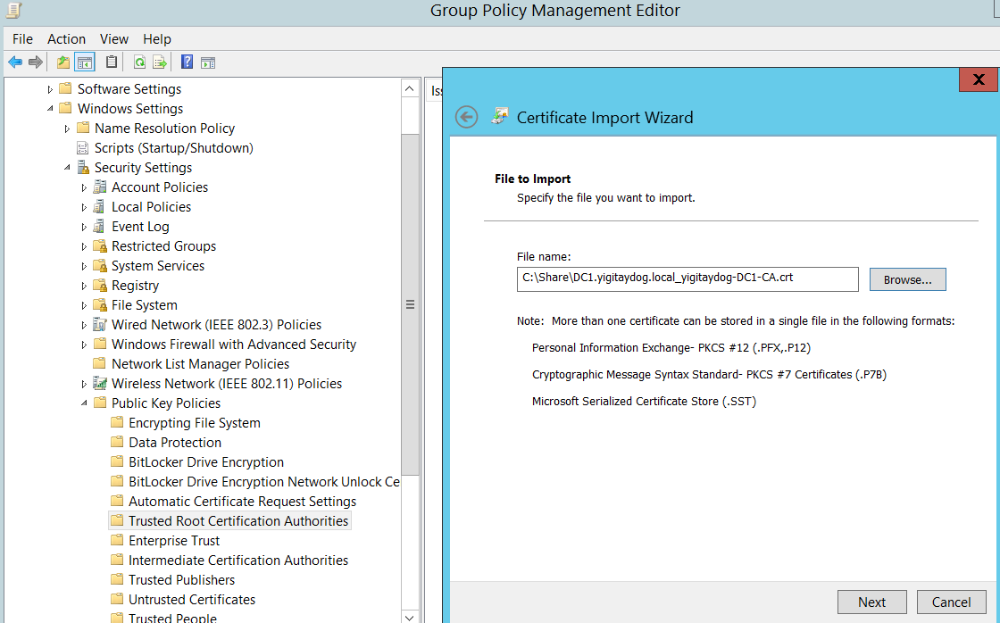

**Configuring Certificate Revocation List Distribution Points**

If a certificate needs to be forcefully expired before its expiration date, it can be revoked by the issuing CA.

Certificates may need to be revoked for any of the following reasons:

* The certificate’s private key has become compromised.
* The CA’s private key has become compromised.
* The certificate was obtained fraudulently.
* The certificate subject (owner of the private key) is no longer trusted or has changed its name.

It won’t always be possible to contact the issuing CA for direct confirmation of a certificate’s validity. To enable alternate methods for a client to check the status of a certificate, AD CS supports publication of a certificate revocation list (CRL) and delta CRLs. These CRLs can be made available to clients from a wide range of different locations including Active Directory Domain Services (AD DS), web servers, and file system shares.

By default, AD CS publishes an updated CRL every seven days to all defined CRL distribution points (CDPs)

The full list of CDPs is included with each certificate when it is issued.

Uses OCSP validation and revocation checking using HTTP

Receives and responds dynamically to individual requests

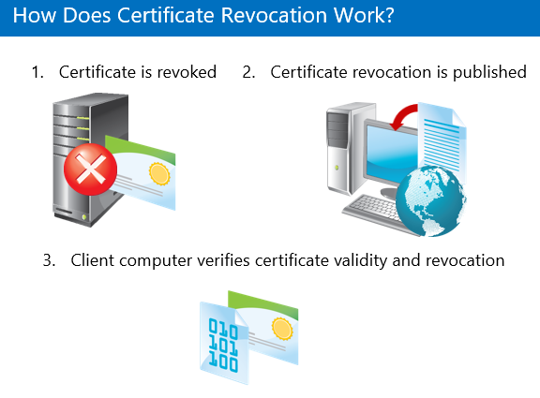

**Creating new CRL Distribution Point**

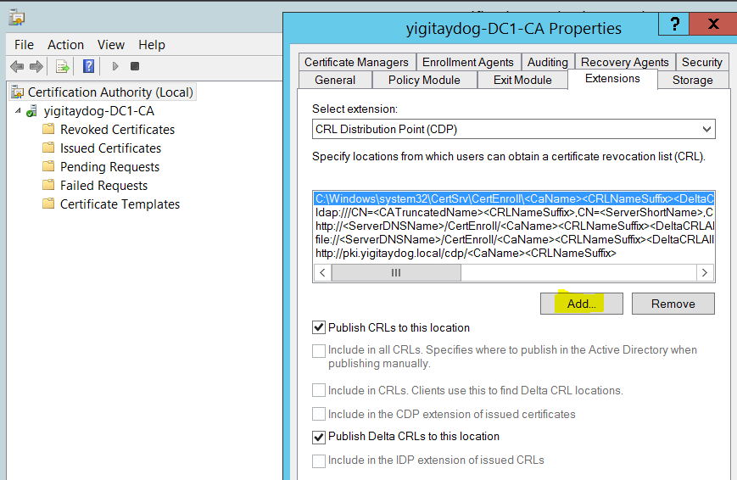

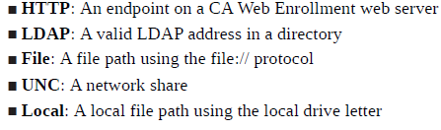

**install and configure Online Responder**

An Online Responder is served as an HTTP service, hosted by IIS, and returns an up-to-date revocation status for a given certificate.

An Online Responder can be installed on an existing CA or a server that does not yet have AD CS installed. Online Responders require Internet Information Services (IIS) to be installed.

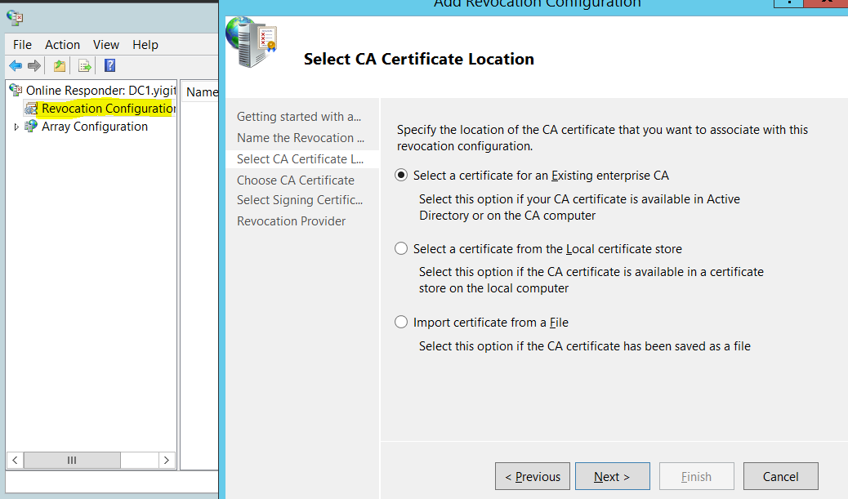

**Automatically select a signing certificate**: The Online Responder selects a signing certificate based on the issuer of the certificate being revoked.

**Manually select a signing certificate**: The Online Responder does not assign any signing certificate, and the user manually selects a signing certificate.

**Use the CA certificate for the revocation configured**: This can be selected if the Online Responder is installed on the same computer as the CA.

**administrative role separation**

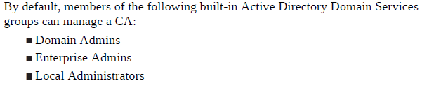

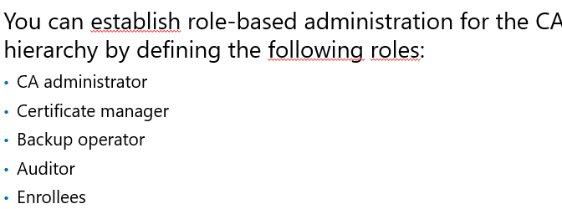

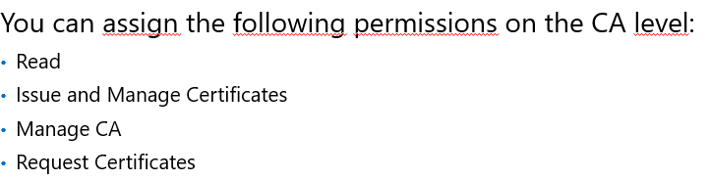

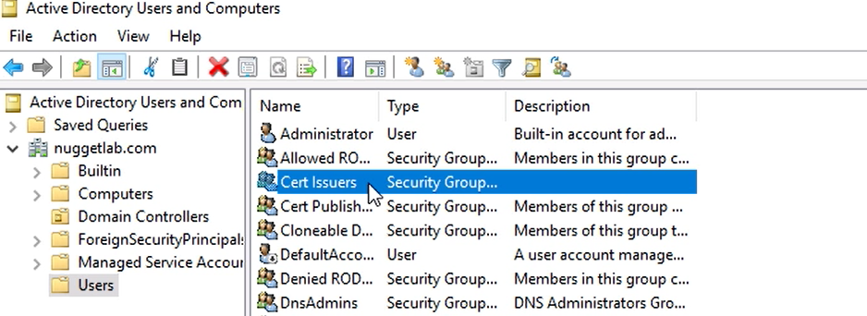

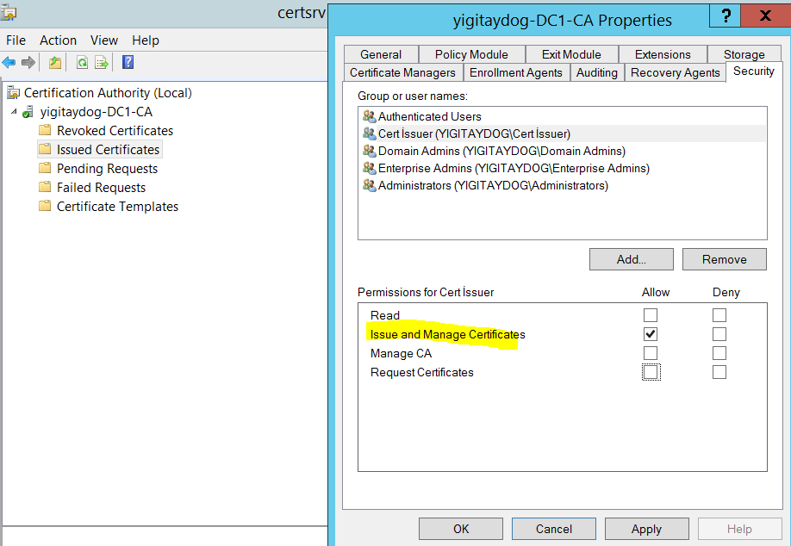

**Read**: Users with this permission can launch the CA console and view the details but not perform any tasks.

**Issue and Manage Certificates**: Users with this permission can issue new certificates and revoke existing certificates.

**Manage CA**: Users with this permission can perform full CA management, including backup and recovery.

**Request Certificates**: Users with this permission can request a certificate from the CA. By default all authenticated users have this permission.

CA backup and recovery

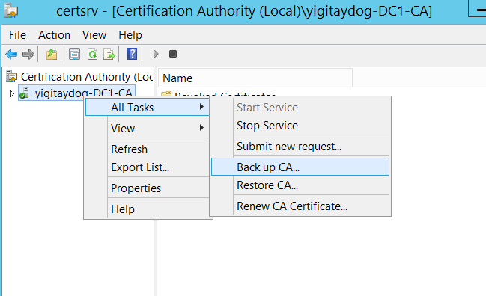

Bu işlem sırasında AD CS durur, restore dan sonra tekrar aktif olur

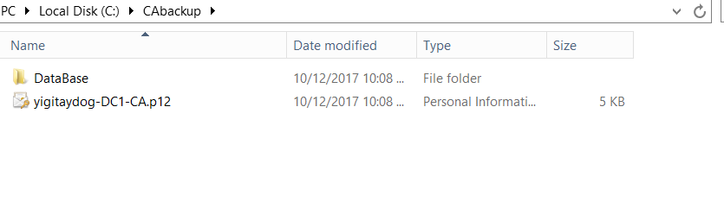

Options

The two options for backing up from the CA console are

**Private Key and CA certificate**: This backs up the CA’s public and private keys and the self-signed certificate used when the CA was installed. This can be used to restore the CA on a new computer if the current host fails.

**Certificate database and certificate database log**: The database allows you to back up and restore certificates that have been issued by the CA.

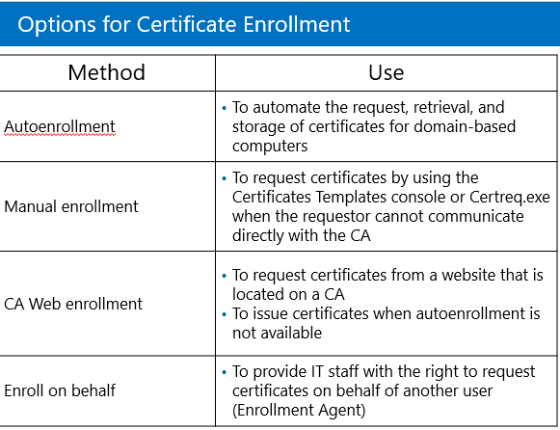

Manage Templates

Certificate templates are only available on enterprise CAs. Standalone CAs cannot use templates as they are stored in the AD DS directory.

Active Directory has a larger number of templates that are accessible only after they have been enabled for a given CA. Enabling a template for one CA does not enable it on other CAs in the domain.

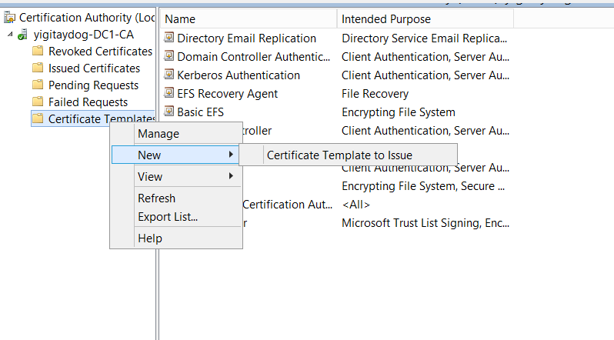

Create Template

Duplicate

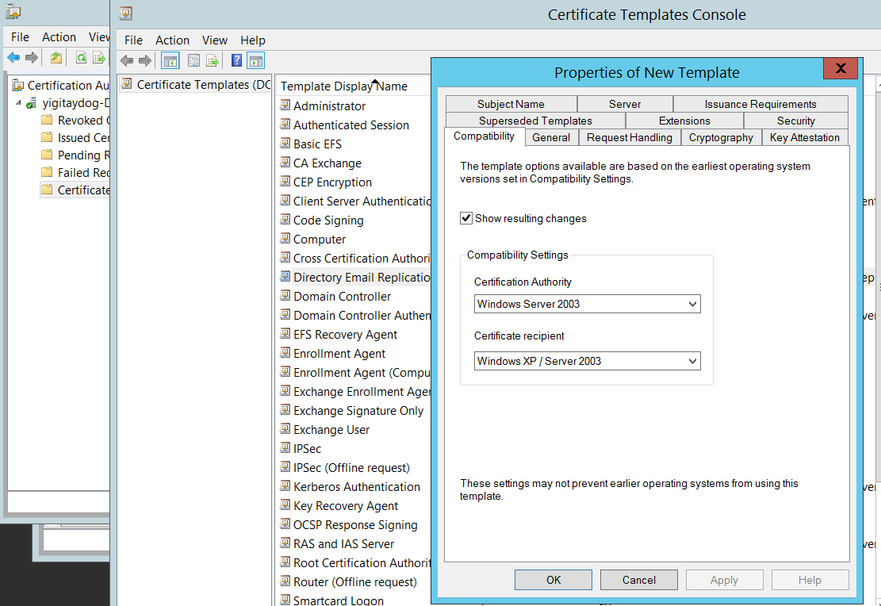

Certificate auto enrollment

The prebuilt templates do not have the autoenroll security option available. You must create a new template to create an auto enrollment certificate.

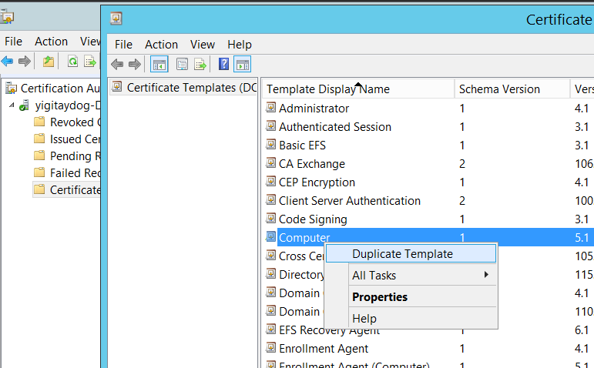

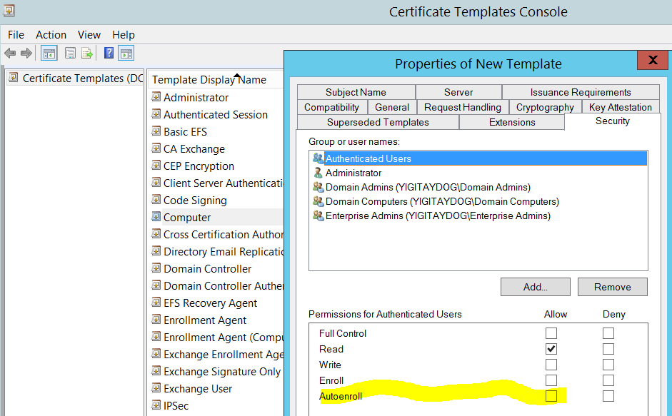

Certificate Templates and select New > Certificate Template to Issue.

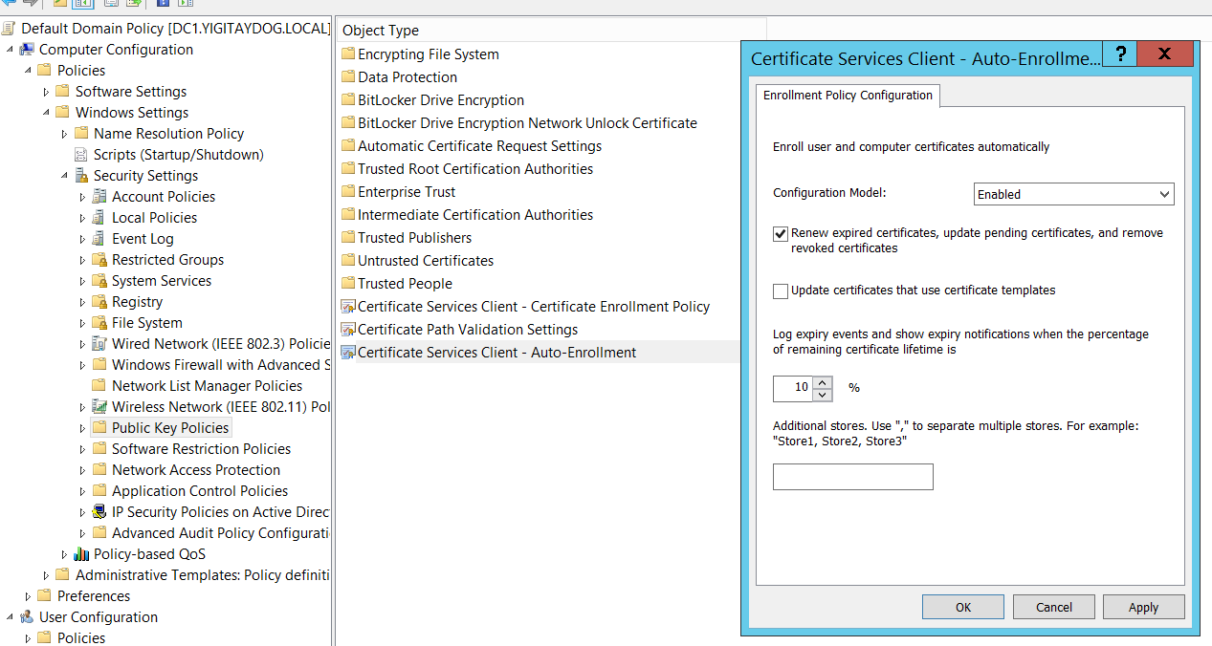

Any object that is included in a link for that GPO and is in the security group enabled for autoenroll on the certificate template now receives the certificate during its next Group Policy update.

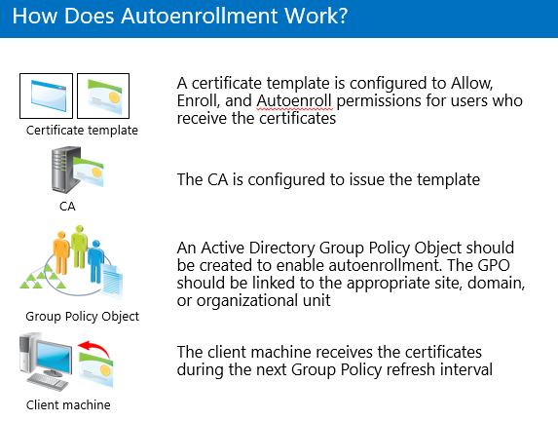

Create Recovery Agent OK

and

Enroll certificate manually

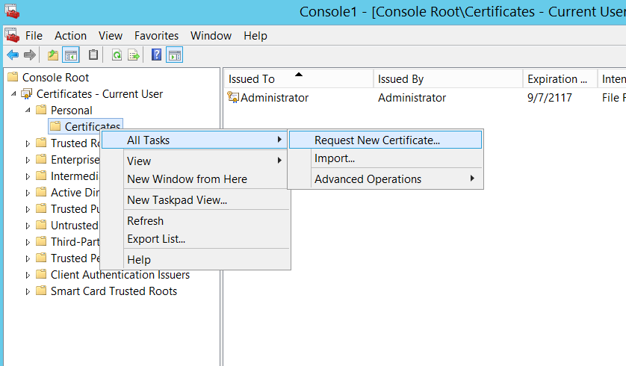

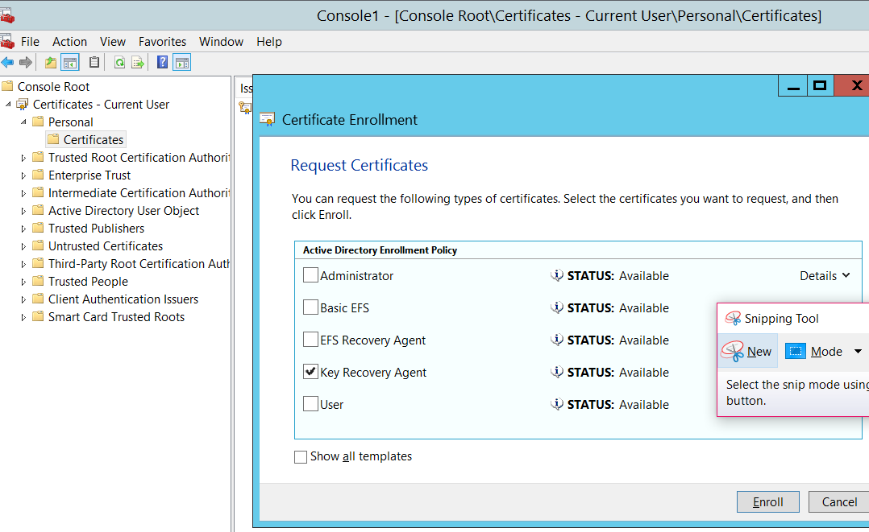

CA Web Enrollment

To use CA web enrollment, you must install the role service with the Add Roles and Services Wizard.

CA server is available at the URL http://<servername>/certsrv.

If the server is already a CA, expand the AD CS node and select Online Responder; then click Next.

If the server is not already a CA, check Active Directory Certificate Services; otherwise, expand Active Directory Certificate Services and check the Certification Authority Web Enrollment

Karşı sunucuda certificaton authority web enrollment kurulur

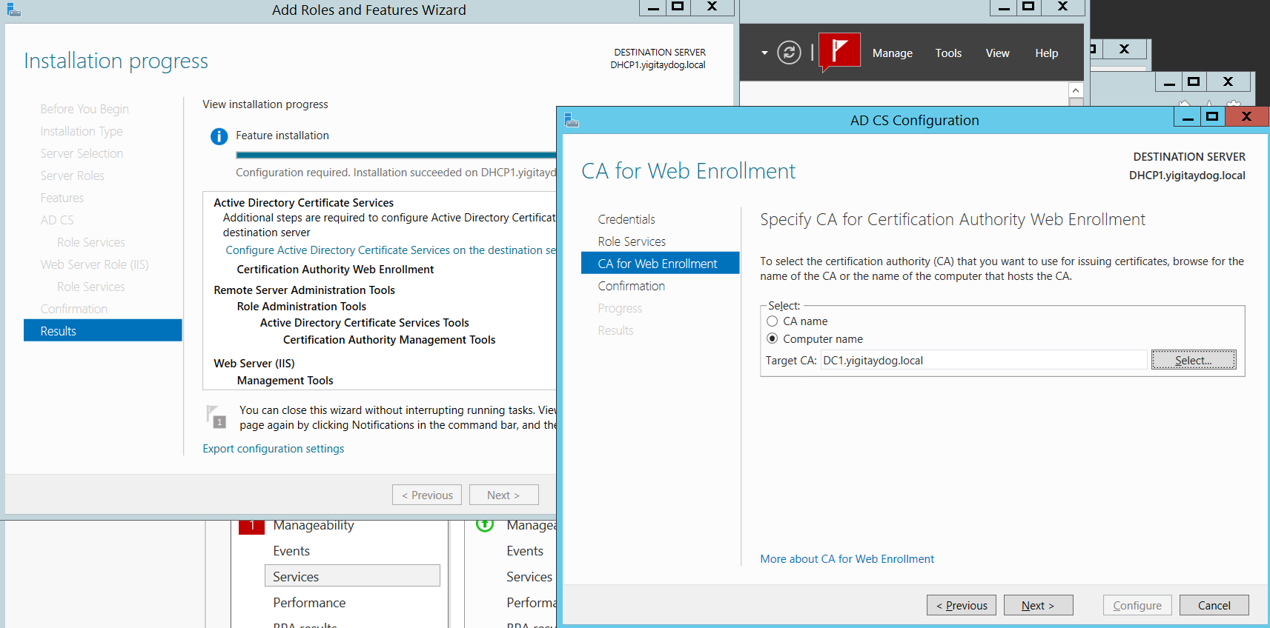

To request a certificate from the CA web enrollment server:

Launch a web browser and navigate to http://<*servername*>/certsrv, where <*servername*> is the name of the server where the CA Web Enrollment Role Service was installed

Click Request a certificate.

User Certificate.

Submit.

When the certificate-issued page displays, click Install this certificate.

Revoking a certificate

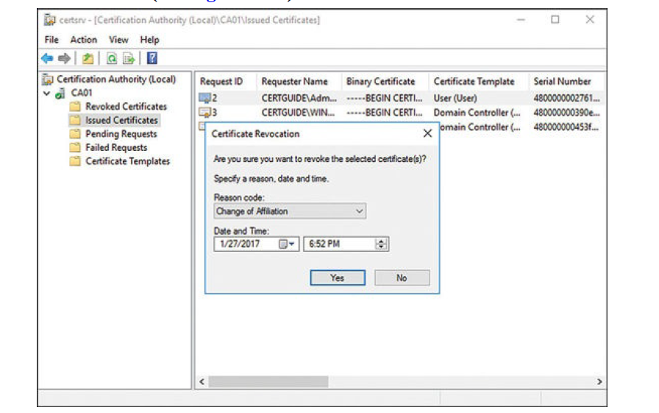

The certificate is not immediately visible in the certificate revocation list (CRL) or delta CRL. The CRL is only updated once every seven days by default, and the delta CRL once every 24 hours. If you want to have the CRL updated sooner, right-click the Revoked Certificates node and select All Tasks > Publish.

KEY ARCHIVAL

In the event a certificate is lost, a Key Recovery Agent (KRA) can use the archived key to reissue the certificate.

Private keys can get lost when:

A user profile is deleted

An operating system is reinstalled

A disk is corrupted

A computer is lost or stolen

It is critical that you archive private keys for certificates that are used for encryption

* create a KRA certificate and enroll a user or users.
* turn on key archival for a CA
* configure a new certificate template with key archival.

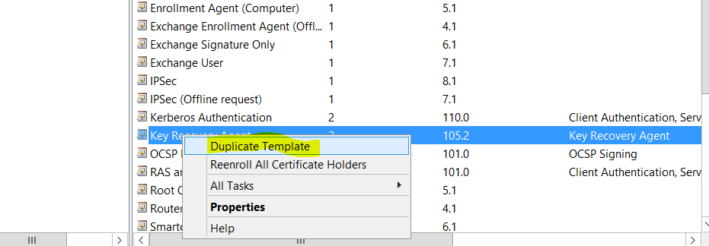

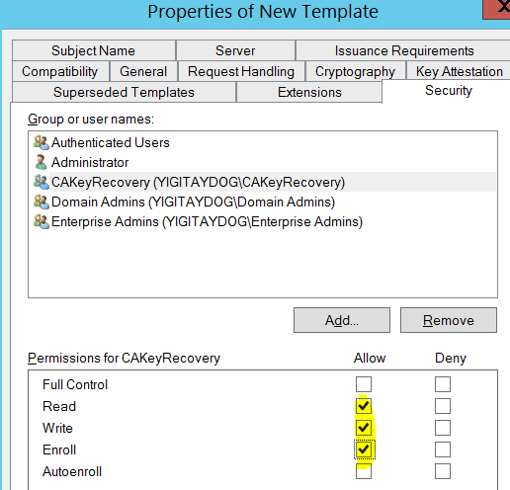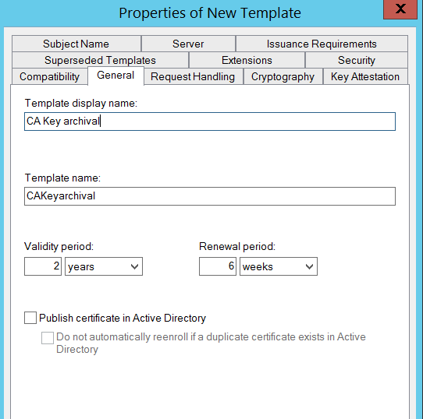

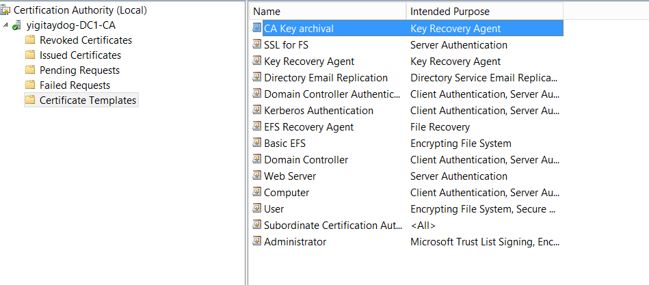

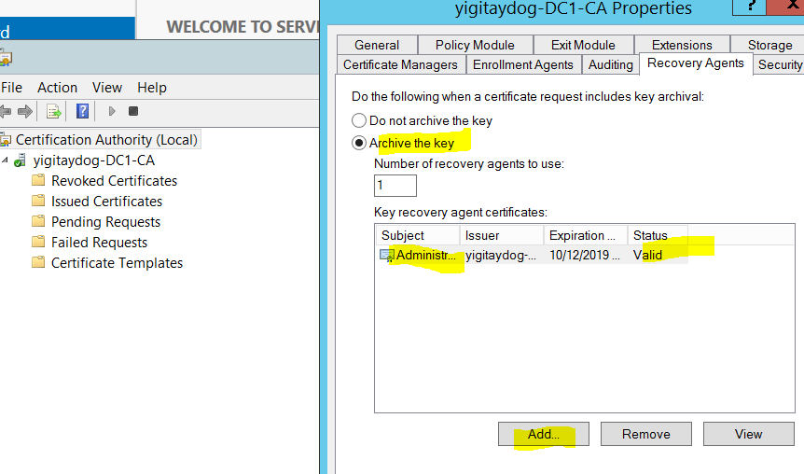

To enable key archival for a CA:

certificate template when duplicating a template. Under the Request Handlingtab, check the Archive subject’s encryption private key box. This causes the CA to archive the key, encrypted by the KRAs chosen previously. Those agents can now recover any certificates issued from this template

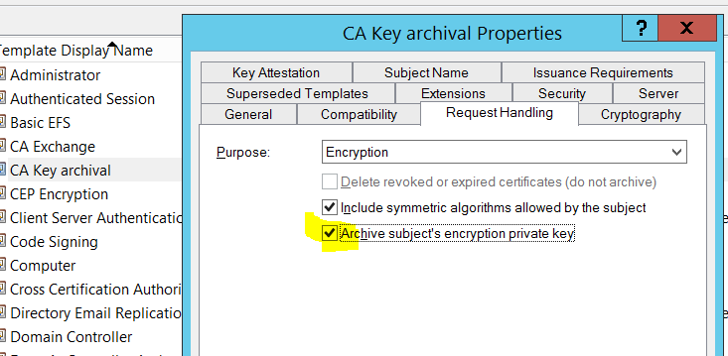

ADFS

AD FS enables authentication (claim based) and authorization across boundaries where AD DS authentication does not work (Kerberos version 5 protocol)

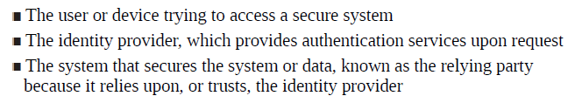

To get a claim from the identity provider, the user must authenticate against the identity provider. Authorization to access the data, however, is controlled by the relying party, which can choose whether to trust the claim and whether the claim asserts the user has appropriate access.

Authenticate> identity provider

Authorization> relying party

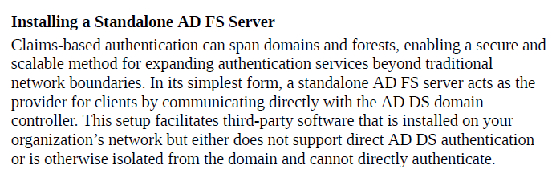

Single Sign on

kullanıcının kimliğini tek seferde doğrulatmak, ardından kimliğini doğrulatmış kullanıcıdan ilgili tüm uygulamalarda bir daha kimlik doğrulaması talep etmemek gerek kullanıcı deneyiminin iyileştirilmesi, gerek bazı güvenlik zafiyetlerinin ortaya çıkmaması adına neredeyse bir zorunluluk halini almıştır.

 birbiriyle ilişkili ancak birbirinden bağımsız uygulamalar için bir **çoklu erişim kontrolüdür**.

SSO in single-corporation

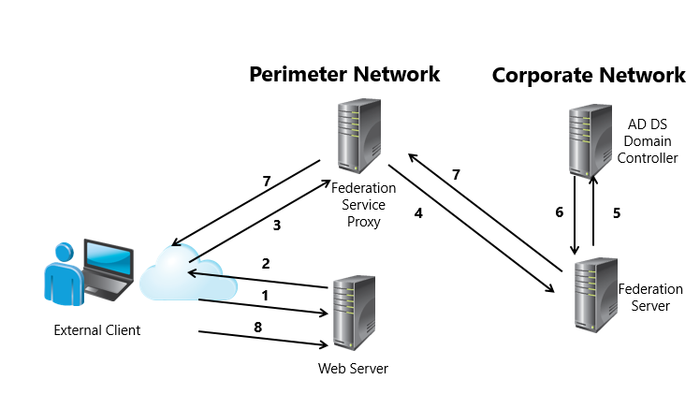

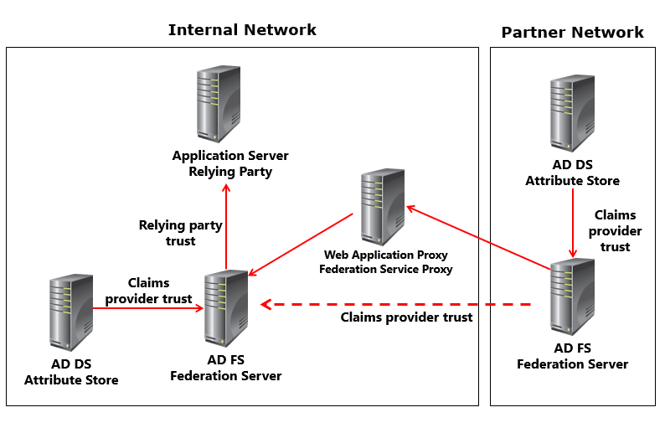

ADFS Kurulumu

DC üzerinde Web server sertifikasının duplicate edilmesi (import seceneğini aktifleştir)

Daha sonra bu sertifikanın manuel olarak enroll edilmesi

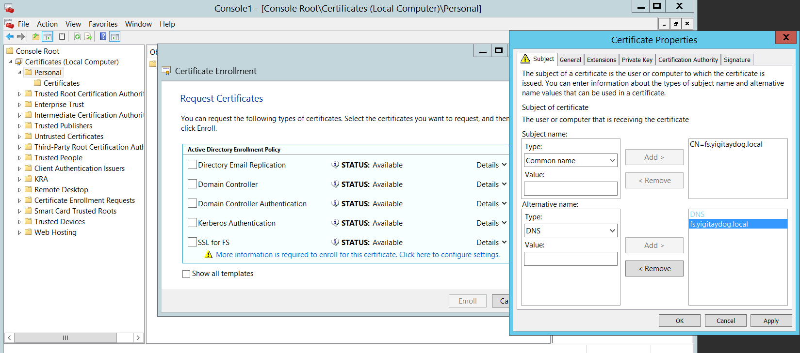

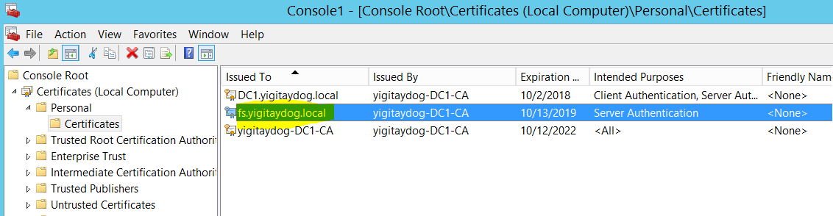

Sertifikanın enroll edilmesi (.fpx)

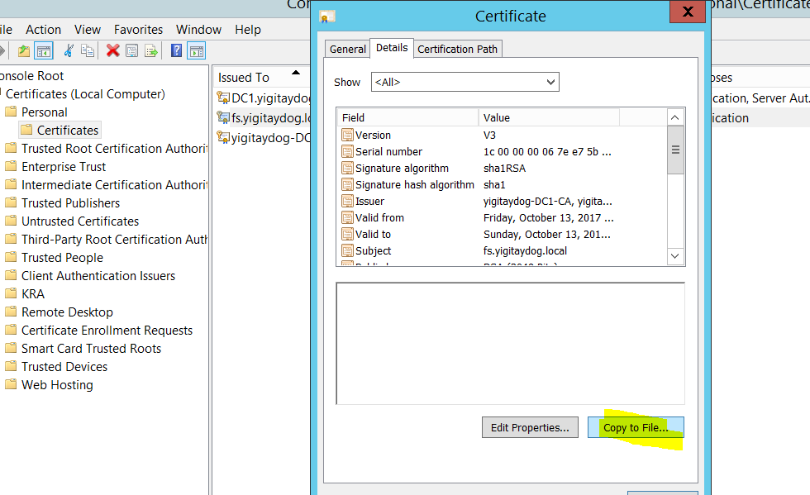

Dc üzerinde AD FS’in kurulması



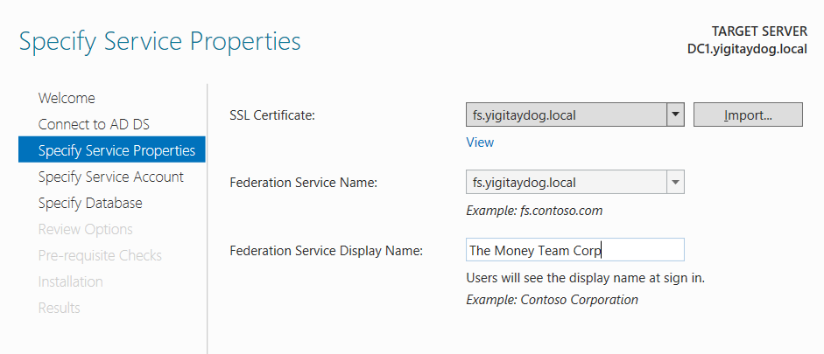

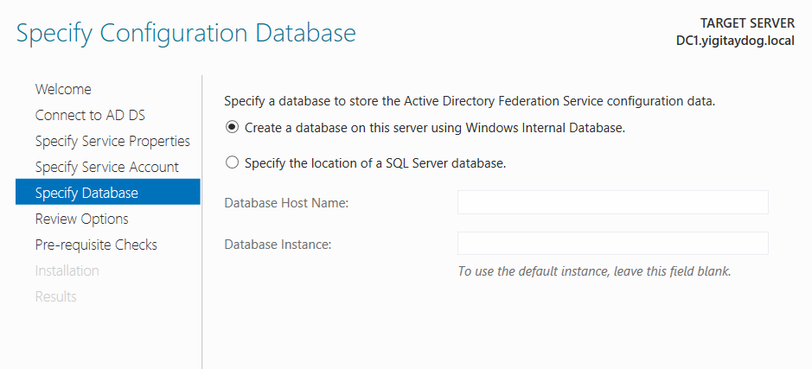

**ADFS Claims Rules**

the claim rules define which attributes you use to populate the claim before sending the claim to the relying party. If you are the relying-party organization, the claim rules define which claims you will accept.

**authentication policies**

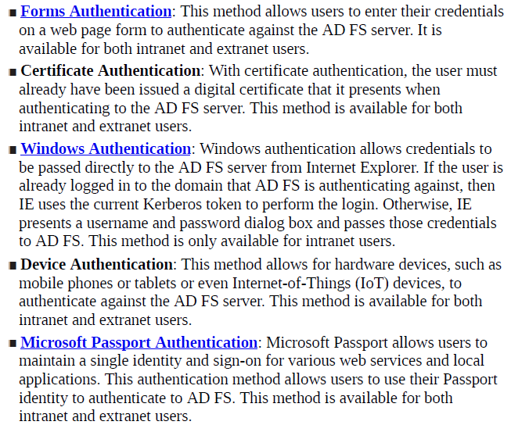

**Service / Authentication Methods**.

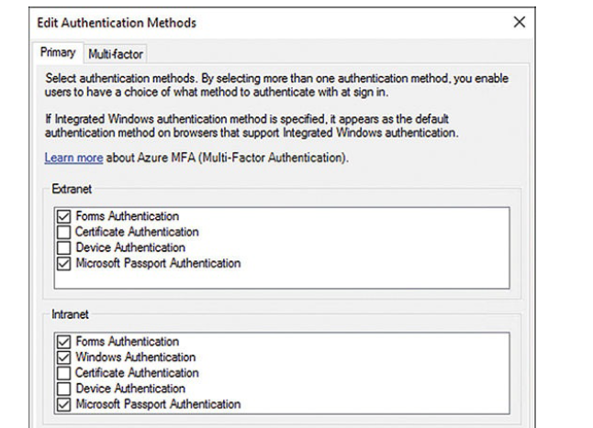

**Multifactor**

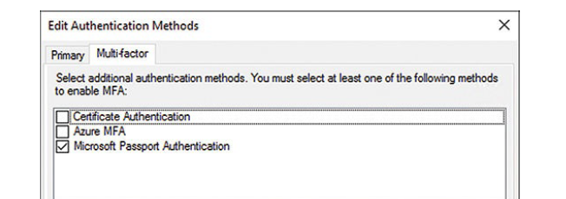

implement and configure device registration

Device Registration Service (DRS) allows users to register their devices with Active Directory.

When a device is registered with DRS, it is issued a digital certificate for authentication purposes.

This is known as Workplace Join and is available for devices running Windows 8.1+, iOS 6.0+, and Android 4.0+

Device Registration requires Windows Server 2012 R2 forest schema

Access Control Policies are a set of one or more rules that define who can and cannot access the DRS

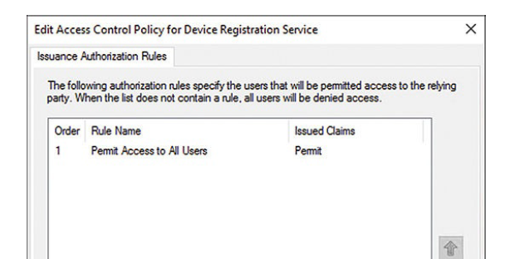

integrate AD FS with Microsoft Passport

Microsoft Passport is available for Windows 10 clients and requires a Windows Server 2016 forest and domain to be integrated with AD FS.

**GPO**

Configuration > Policies > Administrative Templates > Windows Components > Device Registration

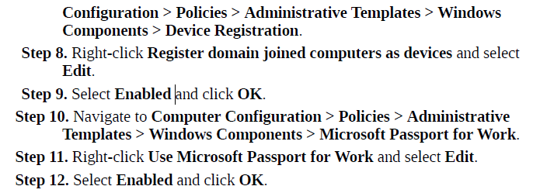

configure AD FS to enable authentication of users stored in LDAP directories

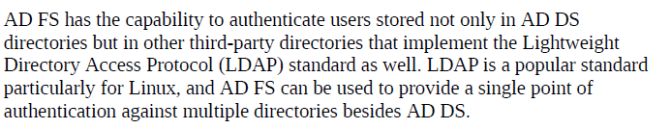

A claims provider trust is a trust relationship that tells AD FS to trust the third-party provider

**WEB APPLICATION PROXY (WAP) >> remoteaccess rolü kurulmalı**

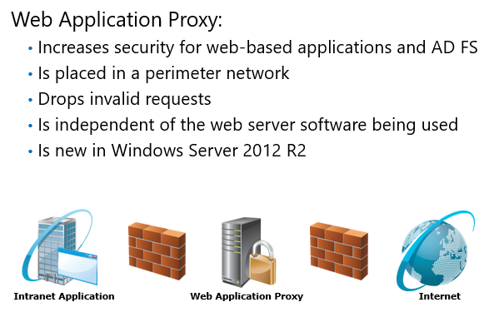

preauthentication for an application by using AD FS. This ensures that a user authenticates before requests are passed to an internal network

The same certificate is used on the AD FS server and Web Application Proxy

Non ADFS server’ı uzeri üzerine kurulur

ADFS üzerinde

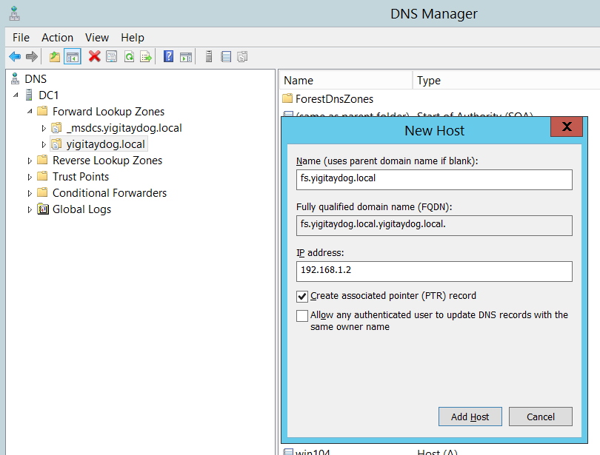

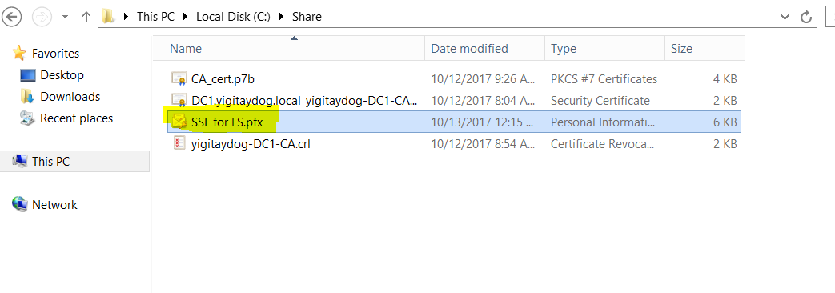

Bu sertifika WAP kurulacak olan sunucuda yüklenir

Server Roles> Remote Access > Web Application Proxy

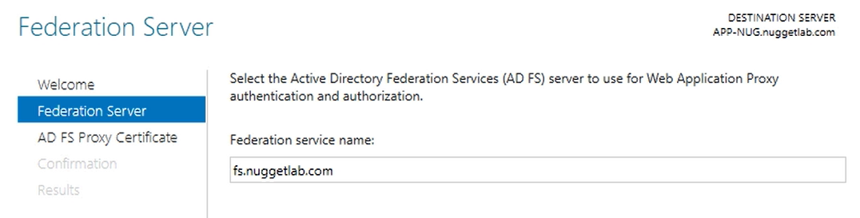

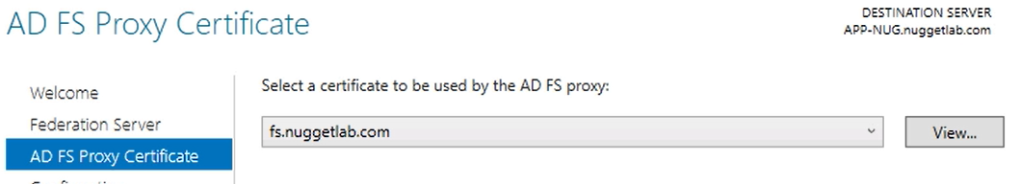

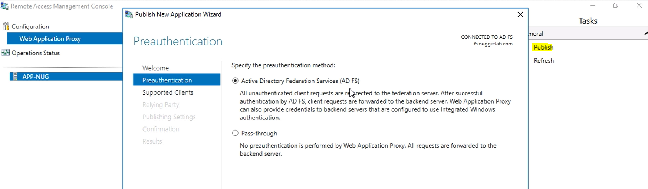

Pass-Through Mode

simply forward appropriate incoming connections to the backend web application and let that application handle any authentication that needs to be performed. This is called pass-through mode.

WAP AS ADFS Proxy

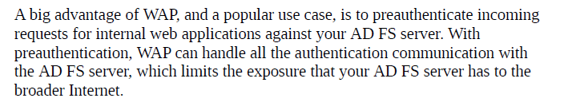

AD FS Console.> Add Relying Party Trust

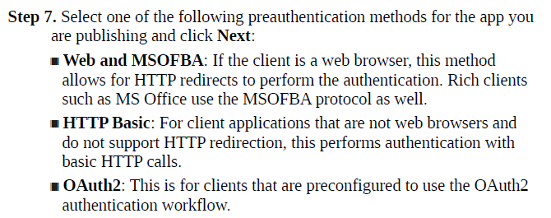

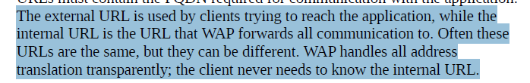

**Active Directory Rights Management Services**

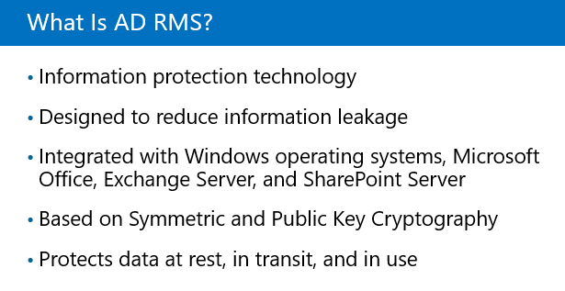

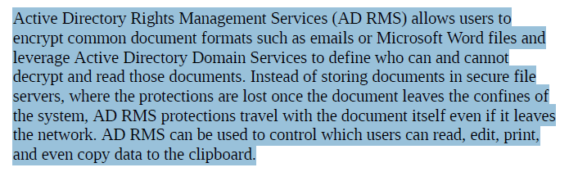

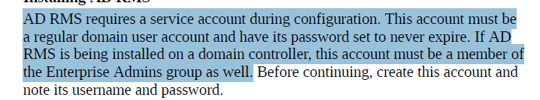

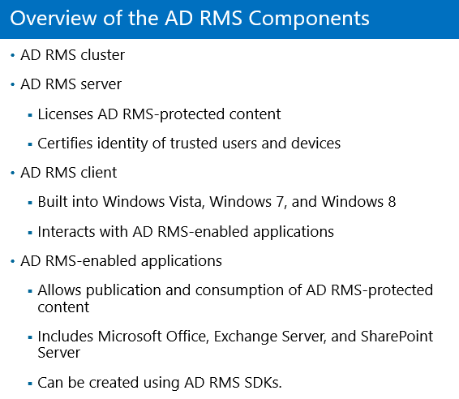

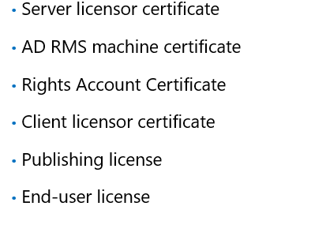

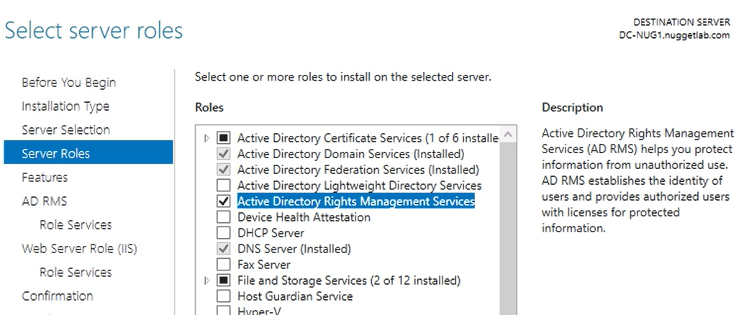

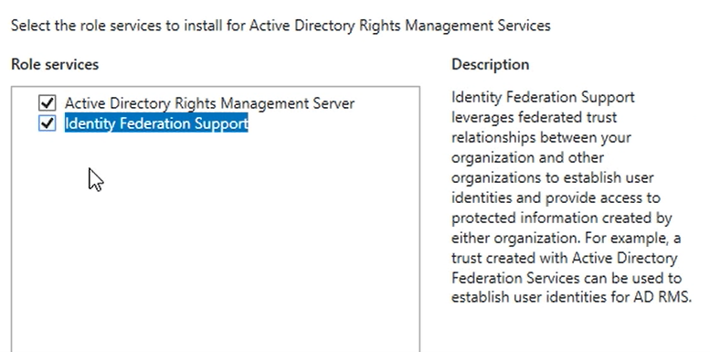

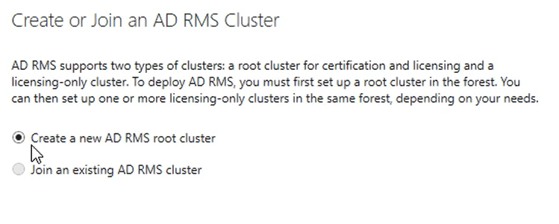



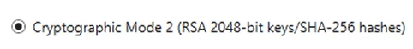

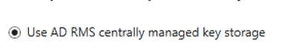

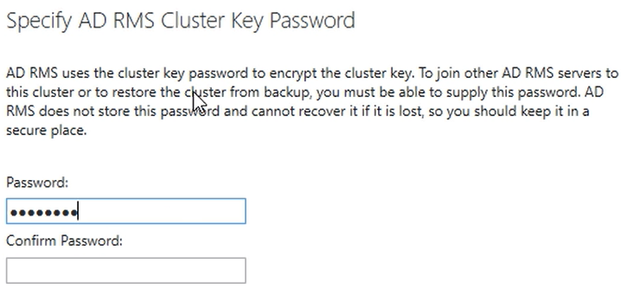

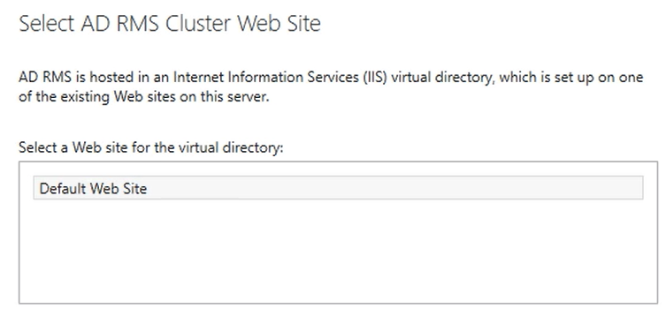

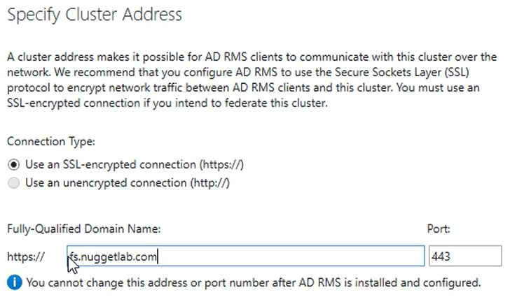

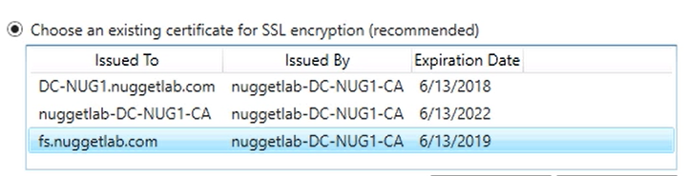

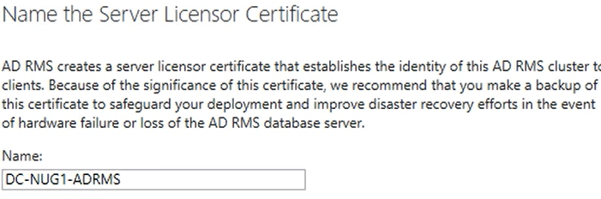

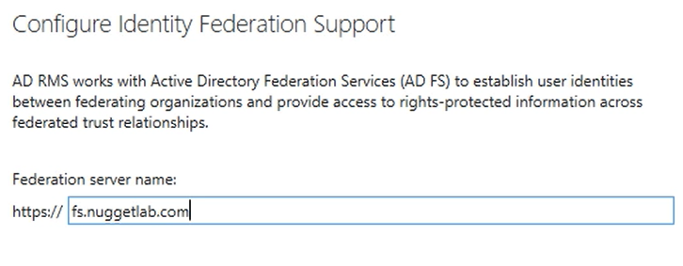

manage AD RMS Service Connection Point (SCP)

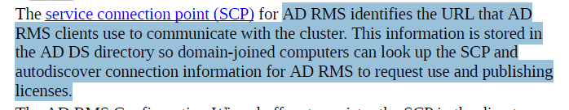

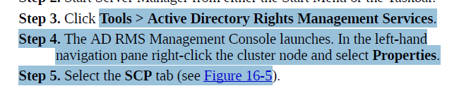

**manage AD RMS templates, configure Exclusion Policies**

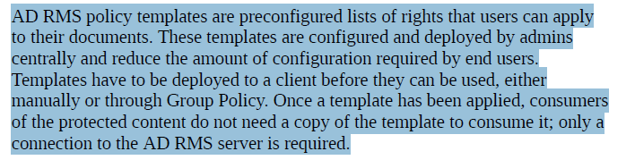

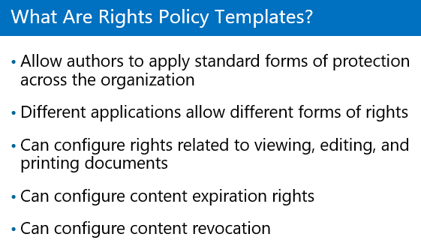

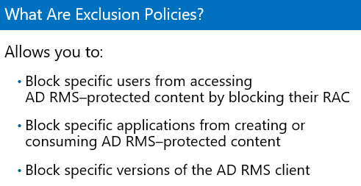

**Create Distributed Rights Policy Template**.

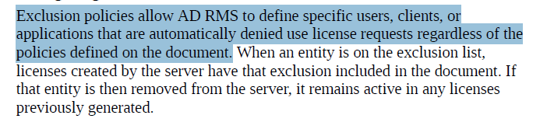

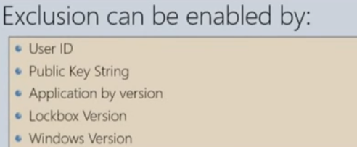

**Console>> Manage AD RMS user exclusion list**.

**Trusted Publishing Domain**

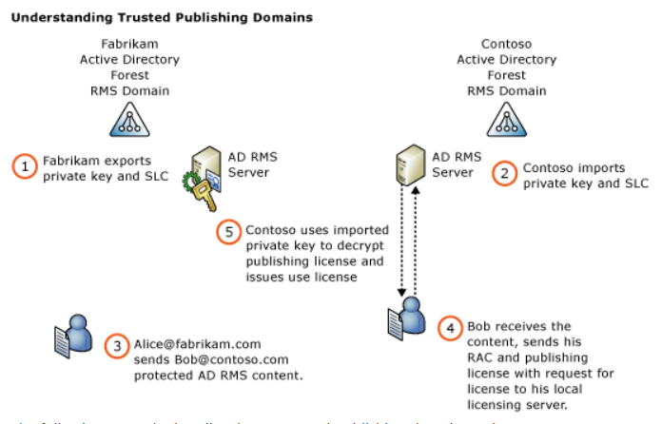

**Trusted User Domain**

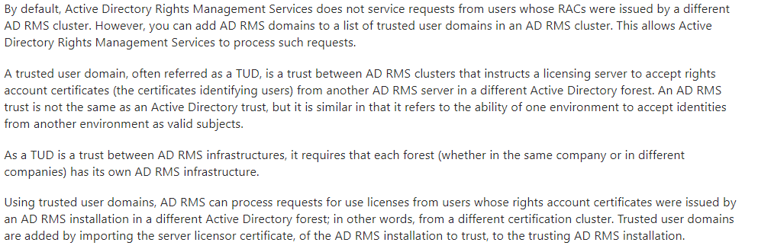

**POWERSHELL MISC**

**Active Directory uygulamaları**

Import-Module ActiveDirectory

* Get-ADDomain | Select Forest,DomainMode,ParentDomain,NetBIOSName,PDCEmulator : domain ile ilgili detaylı bilgiye ulaşılır
* Get-ADForest | Select Name,RootDomain,DomainNamingMaster,SchemaMaster : Forest ile ilgili detaylı bilgi
* Get-ADUser Username | Select GivenName,Surname,Name,SID,City,postalcode : kullanıcıya ait bilgileri listeler
* Get-ADUser –Filter {Surname –eq “username”}

Get-ADUser –filter {passwordlastset –le (get-date).adddays(-90)} : 90 gündür şifresini değiştirmeyen kullanıcları listeler

Get-ADuser –Filter {badpwdcount –ge 5’}

Get-ADComputer –filter “Passwordlastset –lt ‘1/1/2015’ ” –Properties* | Select name,passwordlastset : domain içerisinde şifresi belirli bir tarihten önce değiştirilmiş bilgisayar hesaplarını sorgulamak

* Get-ADUser username –Properties PasswordExpired,PasswordLastSet,PasswordNeverExpires
* .... | Set-ADUser –City “istanbul” –postalcode 34000
* Get-ADPrincipalGroupMembership –İdentity username : username kullanıcısının AD grup üyeliklerini listeler
* Add-ADGroupMember –Identity “groupname” –Members “username” : username kullanıcı hesabını groupname grubuna üye yapar

Örnek gruplar >> “Domain Admins” , “Remote Desktop Users”

* Get-ADGroupMember “groupname” –Recursive | Select DistinguishedName : “groupname” adlı grubun üyelerini listeler
* Remove-ADGroupMember –Identity “Groupname” –Members “username” : username kullanıcısını groupname grubundan çıkartır
* New-ADUser –Name “Pelin Can” –GivenName “Pelin” –Surname “Can” –UserPrincipalName [Pcan@mstcorp.local](mailto:Pcan@mstcorp.local) –SamAccountName “Pcan” –Enabled 1 –AccountPassword {Read-Host –AsSecureString “Password”} >> yeni kullanıcı hesabı oluşturur
* Kullanıcı hesabının şifresini resetlemek

Set-ADAccountPassword –Identity username –NewPassword {Read-Host –AsSecureString “NewPassword”}

* Kapatılmış kullanıcı hesabını aktiflestirmek

Enable-ADAccount –Identity username

* Kapatılmış kullanıcı,bilgisayar vb listeler

Search-ADAccount –AccountDisabled

Search-ADAccount –AccountDisabled –UsersOnly

* Disable-ADAccount , Remove ADUser
* Get-ADObject –LDAPFilter “... “ : ldap filtresine göre bilgisayar hesaplarını listeler

….. active directory and users dan elde edilen filtre

* Get-ADDomainController –Server <servername>
* Lokal admin listelemek

invoke-command { net localgroup administrators | where {$_ -AND $_ -notmatch "command completed successfully"} | select -skip 4 }

* Operating system’e göre bilgisayarları çekmek

Get-ADComputer -Filter * -Properties OperatingSystem

**|** where OperatingSystem –eq "Windows Server 2003"

**|select name**

* Belirli bir OU/domain altındaki bilgisayarları listelemek

Get-ADComputer -SearchBase 'OU=GT Client Computers - Win8,OU=All Computers,DC=fw,DC=garanti,DC=com,DC=tr' -Filter * |select name

Get-ADComputer -Filter * -SearchBase "DC=fw,DC=garanti,DC=com,DC=tr"

* Get-ADGroupMember -identity "GROUPNAME" -Recursive | select name >> returns names ıf members of a specific group
* Get-ADGroupMember -identity "GROUPNAME" -Recursive | select SamaccountName >> returns user names of members of a specific group
* Get-ADDomain -Current LoggedOnUser >> gets domain information for the domain of the currently logged on user
* **ACTIVE DIRECTORY SITES AND SERVICES**
* New-AdReplicationSite <sitename> : yeni site oluşturur
* New-AdReplicationSubnet –Name “iprange” –Site <sitename> -Location <locationname> : subnet oluşturur
* Move-ADDirectory –identity <DCname> -Site <sitename> :dc’leri site’lar altına taşır
* New-ADReplicationSiteLink “linkname” SitesIncluded sitename1,sitename2 : site’lar arasında replikasyon linki oluşturur
* Remove-ADReplicationSite “Default-First-Site-Name” : mevcutta gelen site’I siler
* Remove-ADReplicationSiteLink “DEFAUKTIPSITELINK” : mevcutta gelen replikasyon linkini siler